Guidance in responding to children and young people

Sometimes children and young people use the opportunities that arise in education and care settings to share personal information. Recognising and respecting the significance of those moments for children and young people is part of the staff member’s duty of care. Sometimes what is shared will be about serious matters such as abuse or neglect.

Your role in these situations is to do everything you can to enable the young person to share what they wish to share. This means listening respectfully, showing you care by your manner and allowing the child/young person time. Research clearly indicates that a supportive response to children/young people’s disclosure of abuse or neglect contributes in a positive way to their potential long term recovery.

When might children and young people talk with adults about their concerns?

Some children and young people will initiate a conversation with a counsellor or another trusted staff member by themselves. For others this will only happen if staff initiate conversations and some children/young people will only allude to their problems via a range of non verbal methods. For this reason it is important that staff:

• Pay attention to children and young people’s wellbeing and deliberately structure opportunities to ask after their welfare when there isn’t an audience. Open questions such as

Are things going ok for you at the moment? or
You look a bit down - can I help you with anything?

are good examples. (See below for more about ‘open’ and ‘leading’ questions.)

• Take note of the children or young people who seem to deliberately want to stay behind, want to be in your area at lunchtime or connect with you on yard duty. Whenever possible, take these chances to talk rather than rush away yourself or hurry the child/young person away. If it’s not possible for you to talk at that time, let them know you are aware they want to speak with you, that you think it’s important and will follow up with them as soon as you can. Make an effort to do this, preferably before the end of that day.

• Recognise that play, art work and many forms of written work can be used by children and young people to express their sadness, fears or anger. Always follow up concerns raised through such expressions and seek support from senior staff as appropriate.

What might the child or young person be feeling when they share information about abuse or neglect?

A child may experience a range of emotions when disclosing, including:

• Guilt – children/young people often blame themselves for the abuse and may feel guilty for telling someone about it
• Shame – children/young people are often ashamed of the abuse itself, particularly sexual abuse
• Confusion – children/young people may be confused about their feelings for the ‘perpetrator’ particularly if it is a family member
• Fear – children/young people are often fearful of the repercussions of telling. They may be scared of the ‘perpetrator’, that the abuse may recur or that their actions will cause their family to break up.

What are leading and open questions?

Leading questions can usually be answered by a “yes” or “no”. Leading questions tend to
suggest information and ideas (put words in people’s mouths).

Open questions tend to invite information and allow the individual to only say what they wish to say. Open questions keep the conversation open and are rarely answered by a “yes” or “no”.

For example:

Child/young person’s statement | Leading question  | Open question 
I don’t like my uncle looking after me. | Does he make you afraid? | How does he make you feel?
I don’t want to work, my hand hurts. | Is that a cigarette burn on your hand? Did mum or dad do that to you? | Your hand looks sore: how did it happen?
I’m scared to go on the camp with my class. | Has someone in the class been hurting you? | What’s making you feel scared?

Using open questions is the most supportive way of responding to children and young people’s personal disclosures. It is a gentle and respectful approach that protects both the child/young person’s emotions as well as protecting against you influencing what the child/young person wants to say.

Remember the central role you play in these kinds of situations is to support the child/young person. This means that as soon as you think a child/young person is distressed by being asked clarifying questions, you should stop. Reassure them that they don’t have to talk more with you and that you’re going to do everything you can to help them.

What if the child keeps talking after I have formed a suspicion that they have been abused or neglected?

The purpose of your discussion with a child/young person is to support them and to respect their decision to speak with you about matters of importance to them. It is not necessary to ask more clarifying questions once you have formed a view about what your next actions should be. However it is necessary to hear the child/young person out. Interrupting them or cutting the conversation short will not give them the sense of being heard or of being supported that is so important to their wellbeing. When it appears that they have exhausted what they wish to say you can finish with a question such as,

Is there anything else you want me to know? or
Is there something you want to ask me? or
What would you like to happen now?

What should I say when the conversation is finished?

This is a difficult moment for many staff as they want to acknowledge the seriousness of what has been shared with them but they do not want to fall into the trap of making promises or alarming the child/young person with responses that show how impacted they are by what they have been told. Consider saying

Thank you for talking with me.
I’m really pleased you’ve told
me what’s happening /happened to you. I’m going to get advice now about the best way to help you.

Don’t leave a child/young person alone in this situation. Offer to walk them back to class or organise for someone they nominate to accompany them. If more appropriate, allow them to remain where they are in the company of someone they nominate.

What if a child/young person begs me not to do anything or talk with anyone?

Depending on the situation disclosed and the age of the child/young person, consider saying,

You trusted me to tell me about your situation.
I want you to trust me now to find the best help I
can for you.
I’d be letting you down and/or breaking the law if I
kept this a secret.

If you form a suspicion the child/young person is being abused by a family member or other adult into whose care or company they are supposed to return at the end of the day, this poses a risk that will need to be communicated with the Child Abuse Report Line. If you are given information to suggest that parents /caregivers or other adults have been aware of the harm this too is very important information to provide to the Child Abuse Report Line in their risk assessment processes. (Pre-Notification Checklist. Notification checklist)

Alternatively it may be an adult at the site who is causing the child/young person distress or harm in which case the staff member must report this immediately to their site leader so they can follow procedures for responding to allegations involving adults at the site - as well as making a notification where appropriate.
(Protective Practices for Staff in their Interactions with Students)

If the concern involves another child/young person at the site then decisions need to be made with the site leader about what is an appropriate response to that child/young person, their parents, other children/young people at the site and whether there are obligations to report the behaviour to any other agencies.
(Responding to Problem Sexual Behaviour involving Children and Young People)

It may be that the kind of harm described by the child/young person warrants an immediate response from a medical or mental health care provider or a referral for short or long term therapeutic support. (Support Resources)

What if I think I can’t handle the conversation?
Remember it is best if you can manage your emotions for the sake of the child/ young person. However, if you are concerned in this way try to stay calm and consider saying, at an
appropriate break,

Thank you for starting to tell me this - I think
it’s going to really help us if I get someone to
join us so we can hear what you want to say and between us know the best way to help. Would you like to suggest a staff member?

What are examples of open questions that might help gather appropriate information from children/young people – who are able and willing to provide it?

Clearly the age of the child/young person is significant and will influence the language used to frame open questions and how long the child/young person is expected to engage in talking. The following list is not provided to suggest any kind of conversational order. Obviously staff will ask questions most appropriate to how and where the conversation begins - in response to a specific disclosure, to a general appearance, to an incident, to a drawing etc

What’s making you feel frightened /sad /depressed/like
crying/running away?
What’s making you feel like you don’t want to go home
/go to class/ go to…your grandparents’ house/ the
OSHC site/ football practice/ church group...? Where were you when you felt like this?
Where were you when this happened?

Why do you like playing that game?
What’s happening here in the drawing?
Who taught you this game?
Who is that in your drawing?
Where does your story come from?

Tell me more about what happened?
Tell me more about how this happened?
Can you point to where it hurts?
Who is making you feel like this?

Tell me more about what he/she does?
How do you feel about going home /going to class/ to…your grandparents’ house/ the OSHC site/ football practice/ church group...?
Have you felt like this/ experienced this before?
Has this happened before?

Does mummy or daddy know what happened?
Do other people know what’s happened? Was someone else there at the time?

Is there anything else you want me to know? Is there something you want to ask me?
What would you like to happen now?

What is the longer term responsibility in responding to children/young people about whom concerns have been raised?

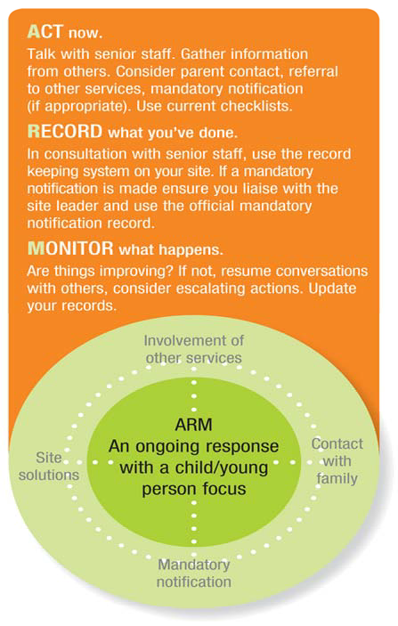
Follow the ARM response (Act Record Monitor)

A referral is made to education - based support services
A therapist works with family members and liaises with site

Such as: modification to teaching and learning programs, student behaviour support plans, professional development for staff,
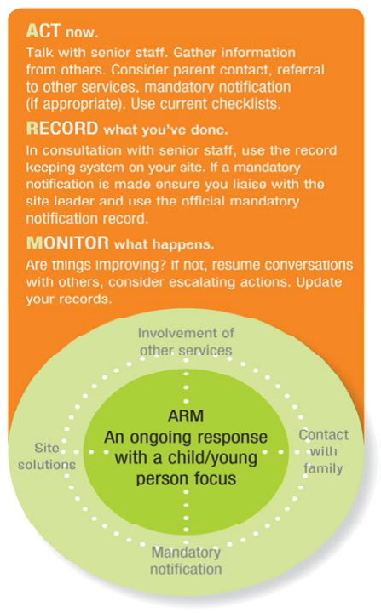
changes to site procedures.
Site leader/ staff member raises concerns with family

Statutory investigation of child’s situation may be made

All available information
& staff
experience contribute to understanding the child’s situation

Monitoring means responses change if the child’s situation changes
Formal records keep track of the actions
taken to support the child and help avoid confusions or duplications

‘Child focus’ keeps actions relevant to child’s needs not the needs of others

Summary guide of the dos and don’ts of appropriate responding when abuse or neglect is disclosed or suspected

Do
• listen with care, show care and use open questions
• find a private place if possible
• be patient, don’t rush them or yourself
• stop asking questions if the child/young person does not want to talk further and/or becomes distressed
• record what you have been told
• speak with a senior member of staff ASAP to help you determine your next actions (for example referral to support services, report to the Child Abuse Report Line, police contact)
• respect their privacy by sharing only relevant information with the people who need to know (Information Sharing Guidelines for promoting the safety and wellbeing of Children, Young People and their Families)
• look after yourself

Don’t
• stop the child from talking or saying what they wish to say
• act scared or shocked
• doubt the child (question the validity of their story)
• threaten to harm or punish the perpetrator
• promise that everything will be fine, that they will be safe, happy, better
• insist that they answer questions, provide more information when unwilling/unable to do so
• ask leading questions or interview others (investigate matters)

All resources listed in this document are available from the DECS website, at http://www.decs.sa.gov.au/speced2/pages/childprotection/

