Guide to developing your Emergency Management Plan

Early Childhood Services and
Non-government schools
2017-18

CONTENTS

Emergency Management Planning 5
Why do facilities need to have an Emergency Management Plan? 5
Emergency defined 6
Purpose of this Guide 7
Establishing your Emergency Management Planning Team 7
Structure of your EMP 8
Customise your EMP 8
Socialise your EMP 9
EMP resources training 9
Developing your Emergency Management Plan 10
1. Purpose and 2. Scope 11
3. Distribution 11
EMP Template: Part 1 - Emergency Response 13
4. In case of emergency 13
5. Emergency contacts 13
6. Incident Management Team 13
7. Incident Management Team responsibilities 15
8. Communication tree 16
9. Staff trained in first aid 17
10. Emergency response procedures 18
11. Response procedures for specific emergencies 21
12. Area map 21
13. Evacuation diagram 23
14. Parent/family contact information 30
15. Children, Students, educators/staff with additional needs 30
EMP Template: Part 2 - Emergency Preparedness 32
16. Early childhood service / School facility profile 32
17. Risk assessment 32
18. Emergency response drills schedule 45
19. Emergency kit checklist 45
20. Additional plan information 46
Other Matters 47
Page numbers 47
Do you need to submit your EMP? 47
Other resources 48
Appendix 1 DET regions 50
Appendix 2 Fire Districts 51
Appendix 3 Emergency Response Drill Observer’s Record 52
Appendix 4 Post Emergency Record 54

Emergency Management Planning

Why do facilities need to have an Emergency Management Plan?
The Department of Education and Training (DET) is committed to providing a safe and secure environment for all children, students and staff. Every education and care service, children’s service (early childhood services) and school in Victoria is required to have an Emergency Management Plan (EMP).
Your EMP records the service’s/school’s emergency management arrangements. A well-developed EMP includes preparedness, prevention and response and recovery strategies, agreed staff emergency management roles and responsibilities, and a site-specific risk assessment.
Approved providers/licencees, educators and staff members in early childhood services and principals, teachers and staff in schools have a duty of care to take reasonable steps to prevent injury to children and students under their care. This duty can be seen to extend to taking reasonable steps to identify, assess and manage risks, and reasonable steps to plan, prepare, respond and recover in an emergency.
Section 21 (1) of the Occupational Health and Safety Act 2004 (OH&S Act) states:
‘An employer must, so far as is reasonably practicable, provide and maintain for employees of the employer a working environment that is safe without risks to health.’
Section 20 (2) of the OH&S Act requires the person who has this duty to take into account such factors as:
- the likelihood of the hazard or risk eventuating
- the degree of harm that would result if the hazard or risk eventuated
- what the person knows, or ought to know, about the hazard or risk and any ways of eliminating or reducing the hazard or risk.
This obligation includes emergencies and the term ‘employee’ also covers contractors, visitors and volunteers.
The success of your response to an emergency will be measured by the timeliness of applying a planned and rehearsed response procedure to an unanticipated incident and the mitigation of adverse consequences.

Early childhood services
For the purpose of this Guide, the term early childhood services includes education and care services regulated under the Education and Care Services National Law Act 2010 and children’s services regulated under the Children’s Services Act 1996.
Education and care services operating under the National Quality Framework (NQF) include kindergartens (pre-schools), long day care services, outside school hours care and family day care services.

Early childhood services operating under the Children’s Services Act 1996 include occasional care and school holiday care services.
The National and Victorian legislation and regulations require services to operate in a way that ensures that every reasonable precaution is taken to protect children being educated and cared for by the service from harm and any hazard likely to cause injury, including responding to potential bushfire risks.
Regulations 97 and 168 (2)(e) of the Education and Care Services National Regulations 2012 require an approved provider of an education and care service to have an emergency and evacuation policy and procedure which includes the following information:
- risk assessment to identify the potential emergencies that are relevant to the school
- instructions for what must be done in the event of an emergency
- emergency and evacuation procedures and a floor plan
Regulation 76 of the Children’s Services Regulations 2009 (Children’s Services Regulations) requires the proprietor of a children’s service to ensure that emergency procedures are developed and regularly practised with staff members and volunteers of the service and children being cared for or educated by the service.
For information about understanding the responsibilities of managing bushfire risks in centre-based and family day care services, refer to the fact sheets available at: www.education.vic.gov.au/childhood/providers/regulation/Pages/nqffactsheets.aspx

Schools
For schools, the minimum registration requirements are specified in the Education and Training Reform Act 2006. Schedule 4 clause 12 of the Education and Training Reform Regulations 2017 states:
‘A registered school must ensure that—
(a) the care, safety and welfare of all students attending the school is in accordance with any applicable State or Commonwealth laws; and
that all staff employed at the school are advised of their obligations under those laws.
In addition, the Victorian Registration and Qualifications Authority’s (VRQA) Minimum Registration Requirements lists a range of evidentiary material in respect of student welfare, including the school’s emergency management plan, which must be reviewed annually.

Emergency defined
An emergency is defined by the Emergency Management Act 2013 as:
‘emergency means an emergency due to the actual or imminent occurrence of an event which in any way endangers or threatens to endanger the safety or health of any person in Victoria or which destroys or damages, or threatens to destroy or damage, any property in Victoria or endangers or threatens to endanger the environment or an element of the environment in Victoria including, without limiting the generality of the foregoing—

- an earthquake, flood, wind-storm or other natural event; and
- a fire; and
- an explosion; and
- a road accident or any other accident; and
- a plague or an epidemic or contamination; and
- a warlike act or act of terrorism, whether directed at Victoria or a part of Victoria or at any other State or Territory of the Commonwealth; and
- a hi-jack, siege or riot; and
- a disruption to an essential service’

The types of hazards and threats schools will address in their Emergency Management Plan will depend on what is identified in their risk assessment.

Purpose of this Guide
This Guide will assist you in developing your EMP. It contains important information and step by step instructions and applies to the templates for:
- early childhood services
- non-government schools

Use of the DET EMP templates is not mandatory for non-government facilities. However, it is strongly recommended for early childhood services on the Bushfire at Risk Register (BARR).
If you chose to use a DET EMP template, you will need to review the information requirements and pre-populated sections and make the necessary adjustments to ensure the information is relevant to your early childhood service or school.
Australian Standard 3745-2010 Planning for emergencies in facilities and the incident control system used by emergency services and government departments in Victoria have been used in the development of both this Guide and the EMP templates.
This Guide does not address business continuity planning but does assume that early childhood services and schools have a business continuity plan in place.

Establishing your Emergency Management Planning Team
In accordance with Australian Standard 3745-2010, your school’s EMP needs to be developed using a team approach. A team approach will ensure that you have adequate resources in place to develop, test and review your EMP. The responsibilities identified for staff involved in this planning process are based on Australian Standard 3745-2010 ‘Planning for Emergencies in Facilities’ and include the following:
- identifying threats and hazards specific to the school and its location and assessing the associated risks to the school community
- developing the EMP
- ensuring that the EMP is easily identifiable and accessible to the relevant people
- establishing an Incident Management Team (IMT) to lead the implementation of your EMP
- ensuring that visitors and contractors are made aware of your school’s emergency response procedures (e.g. through the induction process)
- implementing the EMP, including:
- disseminating information about the EMP and its procedures to staff, students/children, visitors and the school/service community
- ensuring IMT members understand their roles
- testing the EMP (at minimum on a quarterly basis)
- regularly updating the EMP, e.g. to reflect changes to personnel, contact information and procedures
- reviewing the EMP at least once a year
- review and routine servicing of critical and other evacuation system elements
- ensuring that records are kept and retained of all emergencies
- ensuring that records of meetings are kept.

Structure of your EMP
The schools online EMP has been structured into two parts:

- Part 1 - Emergency response
- Part 2 - Emergency preparedness

Part 1 – Emergency response
Part 1 contains all the information you will need in order to respond to an emergency and comprises:
- Emergency contacts
- Incident Management Team structure and contact details
- Incident Management Team roles
- Communication tree
- Educators/staff trained in first aid
- Emergency response procedures
- Response procedures for specific emergencies
- Area map
- Evacuation diagram
- Parent/family contact information
- Children/students and educators/staff with additional needs
The location of these sections at the start of your EMP will help you to quickly access critical emergency response procedures. You are encouraged to make additions or variations based on the specific threats and hazards that could lead to an emergency at your facility.

Part 2 – Emergency preparedness
Part 2 contains important information about your facility:
- Early childhood service/school facility profile
- A site specific risk assessment
- Emergency drills schedule
- Emergency kit checklist
- Emergency Management Plan completion checklist
The Risk Assessment is the most critical part of your plan. It is in this section that you will identify the particular hazards to your early childhood service or school, assess the risks these present to your facility and determine how you will manage them.

Customise your EMP
Where possible, your EMP template has been pre-populated with:
- generic emergency response procedures
- generic responsibilities of roles that need to be assigned before, during and after an emergency.

Please note, these procedures and responsibilities are to be used as a guide only and you should tailor these to your facility’s requirements. As no two emergency events are identical, judgement must be exercised when implementing and managing an emergency response and recovery, having regard to the many factors that can impact on an incident and influence the decisions taken.

Socialise your EMP
Socialising your EMP with organisations and people who may have a role to play during an emergency situation impacting the facility is an essential part of emergency management planning and preparedness.
In addition to members of the facility’s Incident Management Team (see section 6), staff assigned a role in an emergency event (e.g. warden, communications) and other relevant staff, your EMP should be made available to local:
- police
- fire services
- council
Communicating the key aspects of your emergency planning to the wider service/school community will help parents to understand how the facility will respond to an emergency. This will strengthen the community’s confidence in your emergency management planning and help to minimise some of the issues you may encounter when parents are unclear about the facility’s preparedness for emergency events.
It is imperative that your EMP is socialised with any facilities sharing the school site. This will facilitate a coordinated approach to emergency management, for example, alerting the co-located facility of an emergency and coordinating emergency response drills.
Early childhood services
Early childhood services are also encouraged to have regular dialogue and collaborate with surrounding schools and other relevant services on EMP procedures.
Early childhood services should take note that DET has implemented Bushfire Preparedness Relocation or Closure Procedures which apply to government schools only. In exceptional circumstances, some government schools on the BARR may plan to relocate or apply for and be granted approval to close.
In preparing for the Victorian bushfire season it is advisable for education and care services and children’s services on the BARR to liaise with those services and schools, including government schools that are co-located or in close proximity to your service.

EMP resources training
A wide range of EMP resources are available on the DET emergency management planning web page.
The department’s Emergency Management Division delivers training and information sessions to assist early child services and schools in their emergency planning. The program is conducted between late August and early November each year at various metropolitan, regional and rural locations.
Training sessions can also be provided on an ad hoc basis to school network groups by prior arrangement. For more information, contact the Emergency Management Division on 9651 3690 or email emergency.management@edumail.vic.gov.au

Developing your Emergency Management Plan

The level of information contained in your EMP will depend on the risk profile, size, location and operations of your facility. Where possible, uou are encouraged to consult with your local emergency services and local government emergency management staff regarding aspects of your EMP.
Once you have formed your Emergency Management Planning Team, follow the step-by-step instructions on how to complete each section of the early childhood services and schools EMP templates.
As the sections of Part 2 of your EMP (including the risk assessment) relate to preparedness, it is recommended you complete Part 2 as a first step.
Many sections of the EMP template have been pre-populated for your convenience. However, it is important that you customise generic procedures to ensure they reflect your school and its risk profile.

cover page
The Home page of your online EMP will look similar to the one below:
Insert the name of your early childhood service or school (and campus if appropriate) in the space provided on the cover page and update the period the EMP covers. Insert your school or early childhood service logo or a picture of the facility.
If your school has more than one campus (that is not located at the same site) or provides an early childhood service such as an outside school hours care program and/or school holiday program, please note that a separate EMP is required for each service.
The table below will assist you in completing this section of your EMP template.

School No/Service No (SE):
Campus No: | This field appears in the schools template only.
Physical Address | Make sure you insert the physical address and not a post box number or description e.g. ‘corner of High and Main streets’.  The address listed will be the location that emergency services response personnel will be dispatched when responding to a call for assistance.
Phone Number | This is the generic contact number for your school or service
Email address | This is the generic email address for your school or service
DET Region | Select from:  Loddon Mallee Area  Northern Metropolitan Area  Gippsland Area  Southern Metropolitan Area  Eastern Metropolitan Area  Hume Area  Barwon South West Area  Grampians Area  Western Metropolitan Area  See map of DET regions and LGA boundaries in Appendix 1 of this Guide.
Fire District | See map showing Victoria’s nine fire districts in Appendix 2 of this Guide, or click on this link to find your fire district: http://www.cfa.vic.gov.au/warnings-restrictions/find-your-fire-district/
Is the service/school on the Bushfire- At-Risk Register? | Facilities identified as being at significant bushfire risk are listed on the DET Bushfire At-Risk Register (BARR). For a list of early childhood services and schools on the BARR go to: http://www.education.vic.gov.au/about/programs/health/Pages/emergencies.aspx
If on the BARR, which category are you in? | The BARR is separated into categories. Early childhood services and schools on the BARR will be notified which category they are in. This category should be entered here.
Approved Provider/Licensee or Principal Approving our Plan | Insert the name of the person approving the EMP.
Date Approved | Insert the approval date of your EMP by the Early Childhood Approved Provider/Licensee or School Principal.
Next Review Date | Insert the date your EMP will be reviewed and updated.

Contents
The contents page of your EMP template can be automatically updated to reflect changes in the page numbers (refer to Page Numbers section of this Guide for details).

- Purpose and 2. Scope
The Purpose and Scope sections have been pre-populated and provide a concise statement to explain the purpose of your EMP and the people to whom it applies.
Insert the name of your facility as appropriate in the Purpose and Scope sections.
If you wish, you may add additional details to the Purpose or Scope sections to provide contextual or background information, for example a description of the site, details about the general locality, the early childhood service or school demographics, environmental factors and so on.

- Distribution
In section 3 of your EMP template list every staff member and organisation that has been given a copy of your EMP. It is important to keep the list up-to-date so that important changes to your plan can be communicated to key stakeholders.
Distribute your EMP or relevant parts of your EMP to organisations you consider need to be familiar with it should an emergency arise.
An example distribution list is shown below:

Name | Position Title and Organisation Name | Date Sent | Email Address Or  Postal Address
<insert name> | E.g. Chief Warden | <insert date> | <insert email/address>
<insert name> | E.g. Logistics Officer (Warden) | <insert date> | <insert email/address>
<insert name> | E.g. Communications Officer | <insert date> | <insert email/address>
<insert name> | E.g. Operations Officer (Area Warden) | <insert date> | <insert email/address>
<insert name> | E.g. Planning Officer | <insert date> | <insert email/address>
<insert name> | E.g. Service First Aid Officer | <insert date> | <insert email/address>
<insert name> | E.g. Staff Member | <insert date> | <insert email/address>
<insert name> | E.g. Staff Member | <insert date> | <insert email/address>
<insert name> | E.g. DET Quality Assessment and Regulation Division (QARD) (early childhood services only). Contact details of QARD Regional offices are available at www.education.vic.gov.au/childhood/providers/regulation/Pages/nqf.aspx) | <insert date> | <insert email/address>
<insert name> | E.g. Early Childhood Service Responsible Person/Primary Nominee(early childhood services only) | <insert date> | <insert email/address>
<insert name> | Municipal Emergency Response Co-ordinator | <insert date> | <insert email/address>
<insert name> | E.g. Officer In Charge  Local CFA | <insert date> | <insert email/address>
<insert name> | E.g. Officer In Charge  Local Police Station | <insert date> | <insert email/address>

To ensure adherence to the provisions of the Information Privacy Act 2000, please remove any information of a private nature before distributing copies of your EMP to organisations or individuals outside your workplace.

EMP Template: Part 1 - Emergency Response

- In case of emergency
Section 4 of your EMP template is highlighted for easy identification in case of an emergency.
In addition to the phone number for emergency services, provision is made for you to insert the details of any other contact you would call in an emergency for advice and/or support should you need it.
For example, for early childhood services, this may be your approved provider/licensee or person with management or control/licensee representative, while Catholic schools should call the Catholic Education Commission Victoria.

- Emergency contacts
In section 5 of your EMP template, record all the emergency contacts relevant to your facility.
This section comprises:
5.1 Emergency services - Police, Fire and Ambulance.
5.2 Key contacts within your early childhood service or school. Include the contact details of any other facility co-located on your site.
The EMP contains a field for ‘Staff member responsible for Bulk Messaging (where SMS system is in place’). This person may be a different person to the communications person in your Incident Management Team structure. The staff member responsible for bulk messaging should act under the guidance of the communications person in your IMT structure.
5.3 Key organizational/regional/QARD contacts relevant to your facility.
5.4 Key local organisations or services such as local government. In addition to the types of organisations/services provided as examples in the template, include any others that your facility may call upon to assist during an emergency.
5.5 Bus emergency contacts. Insert the details of all the bus routes and contacts relevant to your facility.
Early childhood services with pre-school children who have turned 4 years of age and are also part of the government school bus program can find further information in the fact sheet Transporting Children available at: www.education.vic.gov.au/childhood/providers/regulation/Pages/nqffactsheets.aspx
In the event of an emergency, principals of bus coordinating schools are required to notify client facilities. Client facilities (those with children/students accessing school bus services) will need to notify their bus coordinating school of any change due to an emergency.
For ease of access, a copy of the emergency contacts list should be prominently displayed or readily accessible by appropriate staff, for example, next to your office telephone or on a wall nearby.

- Incident Management Team
Your Incident Management Team (IMT) will direct the way your facility will respond to an emergency.
You can insert a structure diagram of your facility’s IMT in section 6.1 of your EMP template.
The IMT structure referred to in this Guide incorporates elements of the IMT structures used by emergency services and government departments across Victoria and as described in Australian Standard 3745-2010.
You may consider changing the titles of the positions within your IMT structure to best reflect your school’s preferences.
Your designated Chief Warden/Education Commander will take initial charge of an emergency and delegate the other IMT responsibilities until emergency services arrive and take control of the incident. The Chief Warden/Education Commander will need to advise the Incident Controller of the relevant emergency service of:
- the current situation
- what actions have been undertaken
- whether there are any injuries
- what continuing risks have been identified
- what actions you intend to take.

Responsibilities of the IMT are pre-populated in section 7 of the EMP template. These can be modified to meet the needs and size of your school.
IMTs are scalable. For example, in a small facilities there may be insufficient educators/staff for a discrete IMT role to be assigned to an individual. In such cases, educators/staff members can assume multiple roles. As a rule of thumb, consider activating your IMT for every emergency situation. It will be easier to establish your IMT and scale down as required, rather than have too few people involved which may impact on your facility’s ability to respond.
Examples of IMT structures are provided below. To see a tutorial on how to create your IMT structure chart go to: EMP Tutorials.

Example of an IMT structure for a large early childhood service or school

Chief Warden/Education Commander

Communications Officer
Operations Officer (Area Warden)
Planning Officer
Logistics Officer (Warden)

Example of an IMT structure for a medium sized early childhood service or school

Chief Warden/Education Commander

In this example, the Chief Warden /EC performs the roles of Communications Officer and Planning Officer.

Operations Officer
Logistics Officer (Area Warden)

Example of an IMT Structure for a small early childhood service or school

Chief Warden/Education Commander
In this example, the Chief Warden/EC performs the roles of Communications Officer, Planning Officer and Operations Officer (Area Warden)

Logistics Officer (Warden)

Note: You may want to consider also including wellbeing support staff in your IMT structure.

Incident Management Team contact details
In section 6.2 of your EMP template you will need to insert the business and after hours contact details of both your primary and back up IMT members in the table provided. The contact details of IMT members must be kept up to date. The nominated Chief Warden/Education Commander has the task of maintaining currency of the IMT members and their contact details.

- Incident Management Team responsibilities
The responsibilities of each IMT member are pre-populated in section 7 of your EMP template. Your EMP planning team should review the responsibilities and adapt them to your facility’s arrangements and processes as appropriate.
All members of the IMT must understand their assigned responsibilities and practice their role during emergency drills.
You may consider changing the titles of the positions within your IMT structure to best reflect your early childhood service or school’s preferences.

- Communication tree
In section 8 of your EMP template insert a diagram of your facility’s communication tree.
A communication tree enables you to easily identify who at your facility will contact relevant persons or organisations such as parents, emergency services and region/organisation management in the event of an emergency.
A well thought out communication tree provides an easy to follow illustration of who has responsibility for contacting who within your early childhood service or school community and can be of great assistance to anyone who may not be familiar with your workplace procedures. Depending on the size of your early childhood service or school, you may wish to include more than one communication tree in your EMP.
The example of a communication tree provided below can be adapted, copied and pasted into your EMP. To view a tutorial on how to create your communication tree, go to: EMP Tutorials.

Example of an early childhood service communication tree

Responsible Person/
Primary Nominee AH/mobile:

000
Emergency Services

Staff Member AH/mobile:

Approved Provider/Licensee or
Person with Management or Control/Licensee Representative
DET Regional Office/QARD Area Team
Staff Member AH/mobile:

Parents/Person with lawful authority A - E
Parents/Person with lawful authority F - I
Parents/Person with lawful authority J - N
Parents/Person with lawful authority O - Z

Example of a school communication tree

Example of a school communication tree
Principal

Emergency Services
000
School Organisation/ Auspice Body

IMT Members AH/mobile:

Bus Coordinator
AH/mobile:

SMS Manager
AH/mobile:

Neighbouring Schools

Assistant Principal
AH/mobile:
Business Manager
AH/mobile:

Leading Teacher
AH/mobile:

Leading Teacher
AH/mobile:

Admin staff
AH/mobile:

Canteen
AH/mobile:

Staff
AH/mobile:

Staff
AH/mobile:

Staff
AH/mobile:

Parents
Utilities

- Staff trained in first aid
In section 9 of your EMP template list the educators/staff at your facility who have current first aid qualifications and can be called upon should their assistance be required.
Please note that first aid training and assessment of competency needs to be undertaken by appropriately accredited persons prior to first aid staff carrying out responsibilities of the role.
Note: Education and care services must comply with the requirements set out in regulation 136 (first aid qualifications) of the National Regulations and children’s services must comply with the requirements set out in regulation 63 (staff members to have first aid and anaphylaxis management training) of the Children’s Services Regulations.

- Emergency response procedures
During an emergency it may be necessary to activate one or a combination of the following five core emergency procedures:
- on-site evacuation (relocation)
- off-site evacuation
- lock-down
- lock-out
- shelter-in-place

Sections 10.1 to 10.5 of your EMP template have been pre-populated with steps for each of these five core emergency response procedures. You should customise these procedures to incorporate any specific modifications/additions arising from your risk assessment (see Risk Assessment section of this Guide).
The procedures provided are generic. As such, you will need to exercise judgement when implementing any emergency procedures as the particular circumstances of the event need to be considered in your response.
You may consider changing the titles of the positions within your response procedures to best reflect your early childhood service or school’s preferences.
Conducting emergency response drills to test, validate and improve your procedures is an essential part of your school’s emergency management planning (see section 18 of this Guide).
A Post Emergency Record should be completed after an emergency event has occurred. A Post Emergency Record template is provided at Appendix 4 of this Guide.

Early childhood services
Early childhood services are reminded that they must report serious incidents to the relevant DET QARD Area Team in accordance with relevant regulatory requirements. Service agreements also require approved providers or licensees to notify DET in the event of a serious incident.
Education and care services operating under the National Quality Framework (NQF) can refer to the fact sheet Serious incidents and complaints available at:
http://www.education.vic.gov.au/childhood/providers/regulation/Pages/incidents_complaints.aspx
Notifications of serious incidents, incidents and complaints must be submitted online via the National Quality Agenda IT System (NQA ITS) www.acecqa.gov.au/national-quality-agenda-it-system
Children’s services operating under the Children’s Services Act refer to the practice note Serious incidents available at: www.education.vic.gov.au/childhood/providers/regulation/Pages/vcspracnotes.aspx

10.1 On-site evacuation procedure
On-site evacuation/relocation will be necessary if it is unsafe for children, students and staff to remain inside the building. The procedure may be required for an emergency response to incidents such as a small fire, internal gas leak or other threat or hazard confined to a classroom.
This process is often combined with lockout procedure to ensure staff and students do not have access to a high risk area.
Consider the following:
- Wardens / teachers must make their best effort to clear the building and ensure no one remains inside.
- Take your emergency kit/first aid kit (including your children, student and staff attendance lists and a copy of this EMP).
- Once at your primary and/or secondary assembly point/s, check all students, staff and visitors are accounted for.
- All children and students should remain under the direct supervision of staff at the evacuation point to ensure no one returns to evacuated buildings.
- In the event a person(s) cannot be accounted for at the evacuation point, early childhood services and schools must make best efforts to establish the last known location of the missing person(s) including checking with staff, teacher, students, friends, office staff, and conduct a second role check / head count.
- Any person who cannot be accounted for at the evacuation point must be reported to emergency services immediately upon their arrival.
It is recommended that, where possible, you identify more than one on-site evacuation assembly point.

10.2 Off-site evacuation procedure
If it is unsafe for children, students and staff to remain at the facility or on the facility grounds, the early childhood service / school will need to be evacuated to the most appropriate designated off-site assembly point.
An off-site evacuation may be required for an emergency response to incidents such as a bomb threat, fire, chemical spill or flood. Off-site evacuation may also be required as a result of events outside of the facility grounds that can impact on the safety of students and staff, such as factory fire, petrol station incidents, or other industrial or policing incidents.
It is recommended that you identify more than one off-site evacuation point if possible. Consideration should be given to procedures as per above for if a person cannot be accounted for at the evacuation point.

Selecting off-site evacuation assembly points
Some facilities will only have limited options for off-site evacuation assembly points. Where options exist, select an off-site assembly location that offers access to:
- shelter
- water
- toilet facilities
If you are considering using a local government building, make sure you have obtained council approval, understand access and availability restrictions, and that the facility can accommodate all children, students and staff. You may also wish to consider negotiating access to other schools as off-site evacuation locations.
All councils are required to develop Municipal Emergency Management Plans. You should discuss your plan with your local council and provide a copy as appropriate.
The council will be able to provide you with advice about the appropriateness of your off-site evacuation assembly locations and inform you if any other facilities are proposing to use the same sites.
You may also wish to consult with local emergency services when you are determining your evacuation routes and assembly points for both on-site and off-site evacuations.

10.3 Lock-down procedure
A lock-down may be necessary due to an incident that has occurred or is occurring on site or in the local area, and where it is determined it is safest for children, students and staff to stay inside. A lock-down may be required in response to an emergency such as a hazardous smoke emission from a nearby factory fire, severe weather event or a sensitive police operation.
When customising the generic lock-down procedure provided in your EMP template, consider the implications of an extended lock-down. In circumstances where the facility may have to be in lock-down for up to several hours, access to toilet facilities will become an issue. As such, consideration needs to be given to what arrangements need to be made during such times.

10.4 Lock-out procedure
A lock-out may be used when an internal and immediate danger is identified and it is determined that children, students and staff should be excluded from buildings for their safety. For example, it may be unsafe for people to enter the school due to a gas leak in the facility.

10.5 Shelter-in-place procedure
This protective action refers to both a process and a location. Sheltering-in-place may be used when you have determined that this action provides the best protection from external hazards, such as a severe weather event or intruder threat. In the case of a bushfire, a shelter-in-place location may be considered as an option as a central assembly point prior to evacuation, or as a last resort - when evacuation is no longer a viable option.
The location in which you shelter-in-place, such as during a severe weather event may not be the same location you would use to shelter-in-place from a bushfire or grassfire.
If there is a risk of the fire becoming a threat to the safety of the school population, immediate evacuation off-site must be activated. A shelter-in-place location is NOT a bushfire refuge.
Your shelter-in-place location should be sited away from the most likely approach of a bush or grass fire and the least vulnerable to a potential bushfire attack. If one site is not large enough to accommodate all the students and staff at your facility, you will need to identify additional suitable locations.

Guidance for selecting your shelter-in-place location
A facility’s shelter-in-place location/s will:
- comfortably accommodate all children, students and staff (where this is not possible, select two locations) and anticipate:
  - it may be necessary to remain at the shelter-in-place for anywhere from 30 minutes to two or three hours
  - conditions will become hot and stuffy
  - children and students will need to sit on the floor to avoid fatigue
  - staff will require space to move around and help children and students who need assistance
- have more than one entry and exit point
- be located in a building with radiant heat resistance (primarily for schools on the BARR)
- allow for access by children, students and staff of all abilities

A school’s shelter-in-place location/s should:
- allow for emergency services access
- be sited away from the most likely approach of a bush or grass fire and the least vulnerable to a potential bushfire attack:
  - be located in a position away from the impact of radiant heat (primarily for facilities on the BARR)
  - include construction measures to protect the building from any radiant heat source and ember impact (primarily for facilities on the BARR)
- include toilet and water amenities
You may wish to consult your relevant local emergency service when assessing the most appropriate place on your premises to use if required to shelter-in-place.

- Response procedures for specific emergencies
Sections 11.1-11.11 of your EMP template have been pre-populated with emergency response procedures for specific types of emergencies:
• building fire
• bushfire
• major external emission/spill
• severe weather event
• riverine flooding
• bomb/substance threat (includes Bomb/Substance Threat Phone Checklist)
• earthquake
• intruder
• influenza pandemic

Once you have completed your risk assessment (section 17) and you have identified threats and hazards to your early childhood service or school, your planned preparation for, response to, and recovery from these threats and hazards need to be included in the Response Procedures for Specific Emergencies section of your EMP.
Remove any pre-populated responses to specific emergencies from this section that are not identified in your risk assessment. For example, if your early childhood service or school is in a metropolitan area and will never be at risk of bushfire, delete this from risk from section 11 of your EMP. Add any threats and hazards identified in your risk assessment that are not currently addressed in this section.
You will need to exercise judgement when implementing response procedures during an emergency as the particular circumstances of the event need to be considered in your response.

You may consider changing the titles of the positions within your response procedures to best reflect your school’s preferences.

- Area map
In section 12 of your EMP template insert an area map to show the location of your facility and its off-site evacuation points. Your area map will assist you when selecting the most appropriate evacuation route and off-site assembly points. It should include:
• surrounding streets (including street names)
• exit points from your school
• emergency services access points
• a minimum of two off-site assembly areas (where possible)
• off-site evacuation routes (coloured green)
• major landmarks
• legend
• nearby early childhood services and schools

Your area map should also specify the distance and estimated time it would take to get from your facility to each assembly point (see example area maps below).
You can generate your area map using a computer mapping program (for example from the internet), or if this is not possible, a copy of the relevant map from a street directory will suffice. To view a tutorial on how to create your area map, go to EMP Tutorial.

Example of an area map
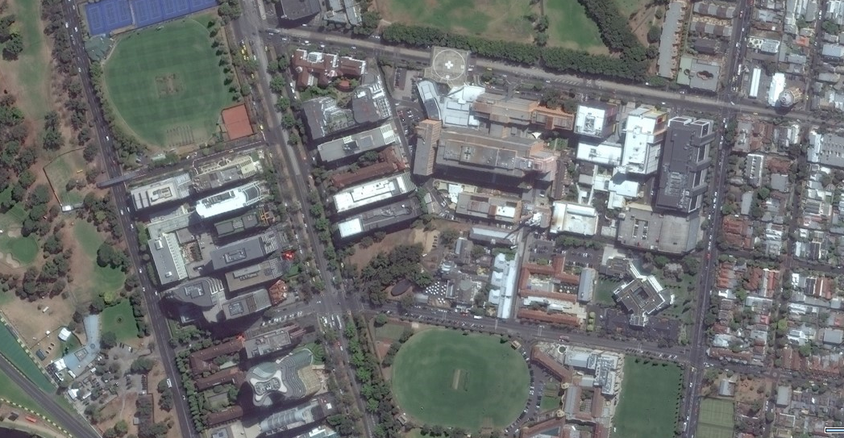

Distance to Primary off-site assembly point: 200m Approx. time to reach Primary off-site assembly point: 10 min

Distance to Secondary off-site assembly point: 250m Approx. time to reach Secondary off-site assembly point: 12 min

Legend:

School Emergency services access point

Primary off-site assembly point Secondary off-site assembly point

Route to Primary off-site assembly point Route to Secondary off-site assembly point

- Evacuation diagram
In section 13 of your EMP template insert the evacuation diagram for your facility.
Evacuation diagrams for each building and floor are required to be displayed in all locations where children, students, educators/staff, visitors and contractors are able to view them, for example, reception area, corridors, classrooms, staff room and so on. (For early childhood services, this requirement is outlined in the National Regulations – regulation 97 and 168). Your EMP planning team should determine the number and siting of evacuation plans required for each building.
In accordance with Australian Standard 3745-2010 Planning for Emergencies in Facilities, evacuation plans must have the following minimum requirements:
- a pictorial diagram of the floor or area (at least 200mm X 150mm in size. Facilities with large floor areas should be prepared in sections so that no more than two exits are shown on each diagram)
- the title EVACUATION DIAGRAM
- the ‘YOU ARE HERE’ location - this will be different for each diagram displayed within the facility. It is sufficient to include a building/floor level diagram in your EMP
- the designated exits, which must be shown in green
- communication equipment locations, for example, Warden Intercom Points (WIPs) which must be shown in red, emergency call points which must be shown in white or have a black border and main panel/controls for warning equipment
- hose reels, which must be shown in red
- extinguishers, which must be shown in red
- fire blankets, which must be shown in red
- fire indicator panel if provided
- designated shelter-in-place location if present
- date diagram was validated
- location of assembly areas
- a legend to reflect the symbols used

You may also wish to include the following optional elements:

- direction of opening of doors on designated exits
- north
- first aid stations and kits (denoted by a white cross on a green background)
- hazardous chemical store
- spill response kits
- evacuation information, for example, procedure as documented in in the EMP, telephone numbers
- paths of travel, coloured green
- specialised evacuation devices, including stairwell evacuation devices if provided
- fire and smoke doors
- hydrants, which must be shown in red
- medical management plans and EPI pens

To view a tutorial on how to create your evacuation diagram and a list of symbols used in evacuation diagrams, go to EMP Tutorial.

Multiple diagrams may be required to show the facility or school in its entirety, including all designated exits and fire equipment.
The ‘Evacuation Procedures for this building/floor’ are procedures that are specific to the building pictured in the diagram you have uploaded.
The ‘Overall Evacuation Procedure’ is that which may be placed in all locations, and may include some of the following details:

Instructions for staff/teachers:
- Close classroom windows
- Leave books/personal belongings and walk briskly in a calm, orderly manner to the instructed assembly area
- Do not allow any child/student to leave the group during an evacuation/lockdown situation
- If any children/students panic and/or disobey instructions by leaving the group, do not follow them but report their absence to the relevant warden at the designated assembly area
- Confirm numbers of children/students present and report missing students (if appropriate)
- Focus on safety and wellbeing of children, students and staff
Instructions for Operations Officer/Wardens:
- Collect epi-pens, asthma kits, personal medications for staff, students and children, and emergency kit with mobile phone
- Collect facility sign-in sheets

Example of an evacuation diagram for an early childhood service
Date Evacuation Diagram Validated: | 1 November 2016

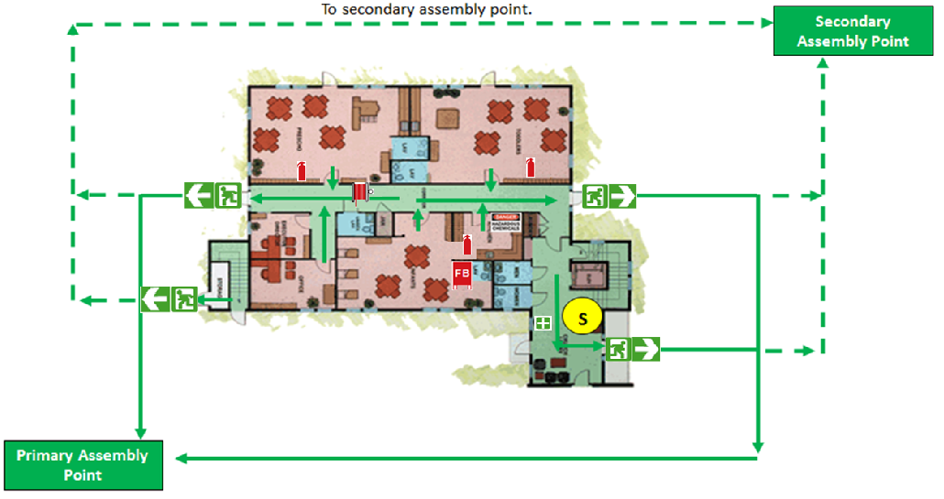
EXAMPLE ONLY

Evacuation Procedures  <insert early childhood service evacuation procedure>  - Do this…..  - Do this…..  - Do this….. | 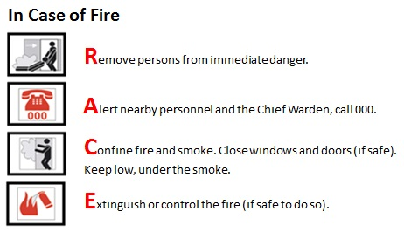

Example of an evacuation diagram for a school

Building Name: | Building C | Date Evacuation Diagram Validated: | 1 November 2015

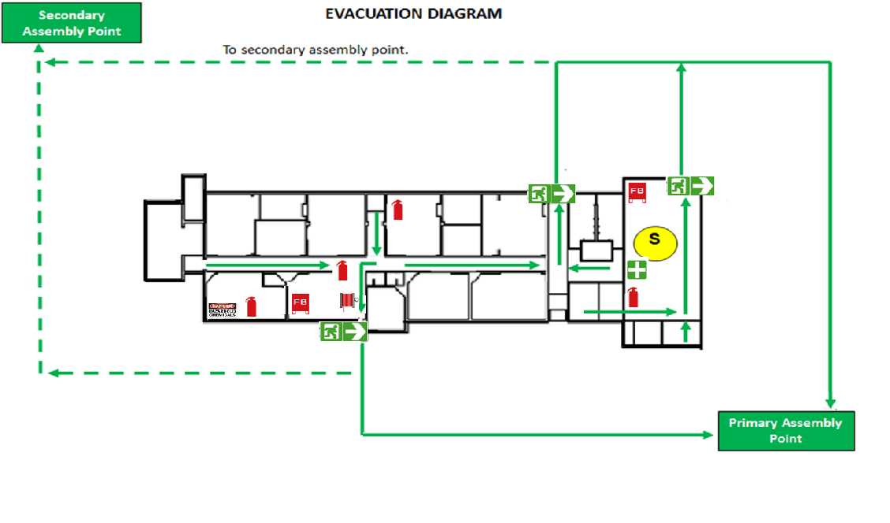
EXAMPLE ONLY

Evacuation Procedure
<insert school evacuation procedure>
- Do this…..
- Do this…..
- Do this…..

- Parent/family contact information
Having up to date parent/family contact information is essential should you need to get in touch in an emergency.
A hard copy of your facility’s current emergency contact list should be included in your Emergency kit (see section 19). A hardcopy of parent/family contact information may also be kept securely offsite. It will be important to have the emergency contact information readily accessible should an emergency situation arise, especially if the emergency requires evacuating the building or site.
If your emergency contact records are kept electronically, ensure you have an updated printout available as you may not be able to access electronic information in the event of an emergency.
To ensure adherence to the provisions of the Information Privacy Act 2000, please remove the parent/family contact information section before distributing copies of your EMP to organisations or individuals outside your workplace.

Early childhood service
Education and care services must comply with the requirements set out in regulation 160 (Child enrolment records to be kept by approved provider and family day care educator) of the National Regulations. This regulation states that enrolment records for each child must include any person who is to be notified of an emergency involving the child if any parent of the child cannot be immediately contacted.
Children’s services must comply with the requirements set out in regulation 31 of the Children’s Services Regulations (Child enrolment records - general) and have a range of parent/guardian contact details, for example, in the case of an emergency.

- Children, Students, educators/staff with additional needs
In section 15 of your EMP template you will need to identify children, students and educators/staff with additional needs who may need assistance in an emergency.
The list must be kept up to date and include individuals who:
- have a medical condition which requires a medical management plan, for example asthma
- have a vision, hearing or ambulatory impairment
- use a wheelchair or scooter
- are easily fatigued

It will also be helpful if you describe in this section:
- diagnosed condition
- the assistance that will be required
- who will be responsible for assisting the child, student or staff member in an emergency?

The sample table below illustrates the how you may wish to record the information:

Students and Staff with a Disability or Additional Needs
Name | Room/ Area | Condition | Assistance needed during an emergency | Who will be responsible?
<insert name> | 5 | Asthma – uses inhaler | Will require assistance and monitoring in heavy smoke | <insert name>
<insert name> | 7 | Impaired vision | Will require assistance during evacuation | <insert name>
<insert name> | Ground | Wheelchair | Will require assistance if located on 1st floor | <insert name>

To ensure adherence to the provisions of the Information Privacy Act 2000, please remove the Children, Students and Staff with Additional Needs section before distributing copies of your EMP to organisations or individuals outside your workplace.
For copies of your EMP to be distributed outside your workplace, you may wish to record a summary of the children, students or educators/staff with additional needs or medical conditions without including the personal details (see table below). This may be of assistance in case of an emergency.

Additional Needs Category | Number of Children/Students | Number of Staff
e.g. Asthma | 4 | 1
e.g. Wheelchair | 1 | 0

EMP Template: Part 2 - Emergency Preparedness

- Early childhood service / School facility profile
Insert your facility profile details in section 16 of your EMP template. The components of this section comprise:
16.1 General information
16.2 Other services / users of site
Provide details here of other users of your facility, for example, community groups during the evening or weekends.
Schools providing early childhood services such as outside school hours care and school holiday programs will need to insert the details of the usage in this section, including days and hours of operation.
Please note, if your school is operating an early childhood service, a separate EMP needs to be completed.
EMP templates specifically developed for early childhood services are available on the DET website: EMP Template.

16.3 Building information summary
In this section you will need to insert:
- the fire and emergency safety features of the building/s on your site, and
- any identified building and site hazards such as science laboratory, cleaner’s cupboard, chemical or fuel storage, technology areas, plant and equipment, steep slopes within the grounds, or any collection of combustible material on the site.

- Risk assessment
Your risk assessment is the cornerstone of your EMP as it addresses the hazards and potential threats specific to your early childhood service or school, the level of risk of each and how you will prepare for, reduce and manage them.
In order to effectively plan for emergencies it is important that you and your EMP planning team are able to identify the hazards to your early childhood service or school and the associated risks they carry that could lead to an emergency at your facility.
If the level of risk is assessed as being at an unacceptable level, you will need to consider how the risk can be reduced to an acceptable level.
Sample risk assessments are provided at the end of this section of the Guide.

Risk assessment steps
Follow the steps below to complete your Risk Assessment table in your EMP template.
Step 1 – Establish the context
This step is included as it follows the DET Risk Management Process and template, located here:
Risk Management Process and template
As your risk assessment is completed in the context of your EMP, this step has already been completed. This is here for your information only.
The context of the risk assessment relates to your facility; the environment, the location, the number of children/students, etc. Use the PESTLE Analysis (political, economic, social, technological, legal, environmental) to analyse the environment and to understand any other factors that contribute to it. Confirm the identity and concerns, issues and expectations of stakeholders. Familiarise yourself with the Department’s tools used to identify, analyse and manage risk.

Step 2 – Risk identification
Identify the specific hazards and potential threats to your facility. Column 1 of the Risk Assessment example table lists the more common types of hazards your facility could encounter.
Please note that the examples provided in the sample risk assessment are not intended to be exhaustive and may not be applicable to every site. Only include in your EMP the hazards/threats that are relevant to your facility.
Some hazards and threats you might consider are:
- Building fire
- Bushfire
- Major external emission/spill
- Intruder
- Bomb/substance threat
- Internal emissions/spill
- Severe weather event
- Earthquake
- Influenza pandemic
- Loss of essential service
- School bus emergencies
- Smoke
- Heat health
- Flood
- Snakes
See the attached risk assessment sample for more guidance.
In Column 2 of the risk assessment table, describe the risk each hazard and potential threat creates for children, students, staff, visitors and contractors at your facility in terms of the probable cause/s and consequence/s of each. Only describe the probable causes and consequences of the risks that are relevant to your facility.

Step 3 – Risk analysis
For each risk, the existing controls currently in place should be captured. In Column 3 of the risk assessment table identify the controls or measures you currently have in place to manage the risks. Only include the controls that are in operation at your facility.
Risk is analysed in terms of consequence and likelihood, taking into account any controls identified.
On the basis of your current controls, use the consequence criteria and likelihood scale tables below to work out the appropriate consequence and likelihood level for each risk.

Consequence criteria
Descriptor | Description
Insignificant | Minor injury requiring no first aid or peer support for stress/trauma event.
Minor | Injury/ill health requiring first aid. Peer support for stress/trauma event.
Moderate | Injury/ill health requiring medical attention. Stress/trauma event requiring professional support.
Major | Injury/ill health requiring hospital admission. Stress/trauma event requiring ongoing clinical support.
Severe | Fatality or permanent disability. Stress/trauma event requiring extensive clinical support for multiple individuals.

Likelihood scale
Note: The Likelihood scale refers to the likelihood of the risk event occurring
Descriptor | Description | Indicative %
Almost certain | Expected to occur | (>95%)
Likely | Probably will occur (no surprise) | (66 – 95%)
Possible | May occur at some stage. | (26 – 65%)
Unlikely | Would be surprising if it occurred | (5 – 25%)
Rare | May never occur | (<5%)

Insert the risk rating of either ‘Low’, ‘Medium’, ‘High’, or ‘Extreme’ in Column 4C along with the appropriate colour code as indicated in the Risk Rating Matrix below.

Risk rating matrix
 |  | Consequence
 |  | Insignificant | Minor | Moderate | Major | Severe
Likelihood | Almost Certain | Medium | High | Extreme | Extreme | Extreme
 | Likely | Medium | Medium | High | Extreme | Extreme
 | Possible | Low | Medium | Medium | High | Extreme
 | Unlikely | Low | Low | Medium | Medium | High
 | Rare | Low | Low | Low | Medium | Medium

The DET Risk Management Process and template includes an ‘Effectiveness of existing controls’ column. This column is not in the template and will not be addressed this year. The 2018-19 EMP will require you to determine the effectiveness of existing controls.

Step 4 – Risk evaluation
Risk evaluation involves comparing the current risk rating found during the analysis process with risk acceptance criteria established by the Department.
Is the level of risk acceptable? Use the table below as a guide. If the level of risk is not acceptable, you will need to identify additional treatments.

Risk acceptability chart

Extreme | Unacceptable (must have Principal / School Council / Regional Office oversight
High | Tolerable (with Principal Class Officer review)
Medium | Tolerable (with frequent risk owner review)
Low | Acceptable (with periodic review)

Risks rated Low or Medium do not necessarily require further treatments as this level of risk is considered to be acceptable. Risks rated High or Extreme require further treatments to reduce their level of risk to a more acceptable level.

Step 5 – Risk Treatment
Risk treatment involves a cyclical process of:
- Assessing the risks
- Deciding whether the risk levels are acceptable (by reference to the Acceptability Chart)
- If not, determine appropriate risk treatment options
- Implementing risk treatments.
Options for risk treatment include:
- Share – if practical to do so, share the risk (eg, outsourcing or insurance)
- Terminate – cease the activity
- Accept – risk acceptance requires appropriate authority
- Reduce – reduce the risk level by applying additional treatments until the risk is acceptable.
Insert any additional treatments or measures to manage or reduce the risk in Column 5 of your risk assessment table. Only include those treatments you will be implementing.
A second assessment is then made to confirm the treatments will reduce the level of risk. This second level of risk is called the ‘target assessment’ – where you expect the risk level to be once your treatments have been implemented. Once implemented, treatments become existing controls. Re-assess the level of your risk in Column 6 on the basis of the new treatments.

Step 6 – Communication and consultation
Communication and consultation with all relevant internal and external stakeholders should take place during all stages of the risk management process.

Step 7 – Monitoring and review
Monitoring and review should be a planned part of the risk management process and should take place at intervals appropriate to the nature of the objective and the level of risk.

A clear assessment of the hazards to your early childhood service or school, and identification of strategies to reduce the risk, will ensure that you are better prepared to respond to an actual emergency.

Example of a risk assessment for early childhood services

1. Identified Hazard | 2. Description of Risk | - Current control measures implemented at our early childhood service | - Risk Rating |  |  | 5. Treatments to be Implemented | - Revised Risk Rating after implementing Treatments
 |  |  | A  Consequence | B  Likelihood | C  Risk Level |  | A  Consequence | B  Likelihood | C  Risk  Level
Only include in your EMP those hazards that are applicable to your early childhood service  The examples provided below are not intended to be exhaustive. |  | Only include in this column those controls that have actually been implemented in your early childhood service.  If you choose to use any of the examples below, make sure the wording describes the situation in your workplace. |  |  |  | Measures to be taken by our early childhood service to eliminate or reduce impact of the risk
Bushfire | Probable Cause:  Identify the key cause/s e.g.:  - Lightning strike  - Arson  - Bushfire rapidly spreading from forest in close proximity to the ECS  - Spark ignited by machinery  - Power line failure  - Escaped planned burn  Probable Consequences:  Identify the key consequence/s e.g.:  - Fatality and/or permanent disability from burns  - Serious injury from smoke inhalation  - Stress or psychological injury requiring clinical support for multiple individuals | - Weekly check of safety equip during bushfire season.  - Liaison with local fire services regarding clearing trees, building safety prior to start of the bushfire season.  - Check CFA website, alerts during the bushfire season.  - Conduct evacuation drills in Terms 1 and 4; conduct Shelter-In-Place drill in Term 1.  - Working bees to clear and clean up ECS site twice per year.  - EMP is reviewed and socialised with staff before fire season.  - Staff and parents aware of plan and understand their role within it.  - Utilise ‘Annual facilities bushfire readiness review checklist’ in October to prepare for the bushfire season  - ECS will close on Code Red FDR days | Severe | Possible | High | During an elevated fire danger period ensure a heightened state of readiness. As appropriate, this will include:  - Consultation with local/District CFA to obtain advice on current bushfire conditions that could impact the facility.  - Ensure lines of communication with relevant emergency services are available.  - A staff member will regularly monitor CFA and Bureau of Meteorology websites, listen to ABC local radio and check the VicRoads website for road closures.  - Consider cancelling staff travel during work hours.  - Consider cancelling excursions.  - Review FDR for week ahead at staff meetings | Severe | Unlikely | Medium
Grassfire | Probable Cause:  Identify the key cause/s e.g.:  - Intentional or accidental ignition of unmanaged dry/dead grass in summer months  - Farmland  - Vacant property  - Managed vegetation in parkland  Probable Consequences:  Identify the key consequence/s e.g.:  - Physical injury to staff or students  - Stress or psychological injury requiring clinical support for multiple individuals | - Liaise with local fire services regarding clearing trees, building safety and so on.  - Check CFA website, alerts during the bushfire season.  - Emergency shelter-in-place/evacuation drills occur in Terms 1 and 4 in advance of the bushfire season.  - Engage with local CFA for information regarding best practice for response |  |  |  | You will need to determine the risk rating for this hazard. If your risk level is ‘High’ or ‘Extreme’, you will need to implement treatments and re-assess the risk to your ECS.
Building Fire | Probable Cause:  Identify the key cause/s e.g.:  - Inappropriate management of stored chemicals such as cleaning fluids  - Incident in science laboratory  - Exploding gas tank  - Faulty electrical wiring  - Faulty electrical equipment  Probable Consequences:  Identify the key consequence/s e.g.:  - Physical injury to staff or students  - Stress or psychological injury requiring clinical support for multiple individuals | - Fire services equipment (fire hose reels, fire extinguishers, fire blankets, hydrants) is tested and tagged as per Australian Standards.  - A Workplace Inspection is completed once per term to check that exit signs and other emergency equipment is working.  - Communication systems (PA system) tested on a regular basis.  - A fire blanket (tested and tagged to Australian Standards) is available in all kitchen areas.  - All electrical equipment is tested and tagged as per Australian Standards and that frayed leads, damaged equipment and so on. are disposed of in an appropriate manner. | Minor | Possible | Medium | With the types of controls used in this example, the risk level is ‘Medium’, so your ECS would not have to implement treatments and re-assess the risk.
Smoke | Probable Cause:  Identify the key cause/s e.g.:  - Fire at nearby factory or house  - Road accident involving a vehicle transporting a hazardous substance.  - Bushfire  Probable Consequences:  Identify the key consequence/s e.g.:  - Physical injury to staff or students  - Stress or psychological injury requiring clinical support for multiple individuals | - Ensure medical treatment plans for children with pre-existing heart or lung conditions are current and accessible  - Keep medication accessible  - Ensure air conditions allow recirculation of air  You will need to determine the risk rating for this hazard. If your risk level is ‘High’ or ‘Extreme’, you will need to implement treatments and re-assess the risk to your ECS.
Riverine Flooding  ECS is at risk of flooding when local rivers reach a peak of x metres | Recent Flood History:  Cause:  - Significant rainfall  Probable Consequences:  Identify the key consequence/s e.g.:  - Areas/rooms affected/inundated and inaccessible to staff and students.  - Roads flooded/blocked to cars and buses for several hours preventing parents, students and staff getting to or leaving facility.  - Physical injury to staff or students  - Stress or psychological injury requiring clinical support for multiple individuals | - Liaise with SES/local government to identify potential risk.  - Develop contingency for storage of equipment/materials off site or above historical flood levels if necessary.  - Ensure business continuity plan in place if forced to relocate off site. |  |  |  | You will need to determine the risk rating for this hazard. If your risk level is ‘High’ or ‘Extreme’, you will need to implement treatments and re-assess the risk to your ECS.
Severe Weather Event | Probable Cause:  Identify the key cause/s e.g.:  - Electrical storm causing fire.  - High winds causing roof to collapse, limbs to fall from trees and airborne debris shattering windows.  - Rain inundation resulting in unsafe electrical wiring/loss of power and communications.  Probable Consequences:  Identify the key consequence/s e.g.:  - Physical injury to staff or students  - Stress or psychological injury requiring clinical support for multiple individuals | - Regular scheduled maintenance to roofs/gutters/drains to keep clear.  - Liaison with SES/local government to identify potential local risks.  - Contingency for storage of equipment/materials if necessary.  - On the basis of weather forecast, secure loose objects in open areas e.g. garbage bins, play equipment.  - Communications tested.  - Utility shut-off instructions/points are known.  - Back up communications and contact lists maintained in case power fails.  - Condition of large trees regularly checked.  - Shade sail structures regularly checked. |  |  |  | You will need to determine the risk rating for this hazard. If your risk level is ‘High’ or ‘Extreme’, you will need to implement treatments and re-assess the risk to your ECS.
Heatwave | Probable cause:  Identify the key cause/s e.g.:  - Prolonged period of excessively hot weather  Probable Consequences  Identify the key consequence/s e.g.:  - hyperthermia: heat and sunlight overheat human body resulting in heat cramps, heat exhaustion, heat stress and heat stroke.  - dehydration exacerbating existing medical conditions  - power outages due to high use of air-con, refrigeration  - failure of public transport (rail)  - food poisoning due to unrefrigerated lunch | - Sun and UV protection policy as per SPAG as well as SunSmart program  - Playground areas are shaded  - Sufficient shelter available for students awaiting pick-up by parents  - Sufficient unrestricted water available  - Restricted outdoor time during hot days (indoor recess and lunch, sports programs moved to gym/indoor area)  - Staff are trained in identifying early signs of heat stress/dehydration | Major | Possible | High | You will need to determine the risk rating for this hazard. If your risk level is ‘High’ or ‘Extreme’, you will need to implement treatments and re-assess the risk to your ECS. | Moderate | Possible | Medium
Loss of essential services  Power, water or communications | Probable Cause:  Identify the key cause/s e.g.:  - Issue with supply due to storm/accident  - Planned outage  Probable Consequences:  Identify the key consequence/s e.g.:  - Lack of availability of resources such as computers  - Lack of availability of fresh drinking water and water for flushing toilets | - The size and health of trees growing close to power lines are regularly checked and pruned or removed if necessary  - Alternative communication source such as charged mobile phone/satellite phone are available  - Alternate lighting sources, such as a torch or battery operated light are contained in the emergency kit  - A list of emergency phone numbers is located next to all office phones | Moderate | Unlikely | Medium | With the types of controls used in this example, the risk level is ‘Medium’, so your ECS would not have to implement treatments and re-assess the risk.
Bomb/ Substance Threat | Probable Cause:  Identify the key cause/s e.g.:  Known or unknown person with intent or harm or cause fear to staff and students of the ECS  Probable Consequences:  Identify the key consequence/s e.g.:  - Physical injury to staff or students  - Stress or psychological injury requiring clinical support for multiple individuals | - Bomb Threat Checklist located next to each phone.  - Emergency evacuation drills scheduled and practiced on a regular basis.  - Implement bomb/substance threat response as required. |  |  |  | You will need to determine the risk rating for this hazard. If your risk level is ‘High’ or ‘Extreme’, you will need to implement treatments and re-assess the risk to your ECS.
Intruder | Probable Cause:  Identify the key cause/s e.g.:  - Drug affected  - Mental health issues  - Custodial/Parent dispute  - Political views  - Police operation  Probable Consequences:  Identify the key consequence/s e.g.:  - Physical injury to staff or students  - Stress or psychological injury requiring clinical support for multiple individuals | - Visitors must report to reception and sign in using the Visitor Register.  - Visitors are required to wear and display visitor pass/badge.  - Parents must make an appointment to meet with teachers/principal.  - Lockdown/lockout/ evacuation procedures are regularly practiced.  - Values of mutual respect and acceptable parent behaviour policy are communicated and regularly reinforced e.g. at parent forums and in newsletters.  - Encourage engagement of parents in ECS activities.  - In relation to court orders / custody papers:  - the ECS maintains a register of current documents  - parents are advised of the relevant ECS processes and duty of care to other students and staff.  - For parent meetings where staff feel a need for support:  - two staff attend  - staff use a signal to obtain support from another staff member if required  - an appropriate room for meeting selected e.g. one with two exit points . | Major | Possible | High | - The ECS will provide training for staff in managing aggressive people/diffusing tense situations.  - Staff will share information on a ‘need to know’ basis concerning parent issues.  - The ECS will develop a process and pre-determined actions to discretely alert others of an intruder.  - The ECS will increase number of staff on yard duty as required, develop a roster and monitor attendance of yard duty teachers.  - Yard duty staff will be trained to manage intruders on ECS grounds.  - Where necessary, the ECS will seek legal advice and obtain a trespass order for parents who use threatening behaviour.  - Procedures for responding to an intruder are readily accessible to staff.  - If there is an escalation of Intruder incidents, the ECS will consider:  - issuing yard duty staff with two-way radios linked to an office base station  - installing panic/distress button in reception, principal office and/or meeting room  - liaising with local police to arrange a prompt response to any call for assistance  - seeking advice from the DET region and police, and in exceptional circumstances, on engaging a security guard as required  - installing CCTV. | Moderate | Possible | Medium
Major external emission/spill | Probable Cause:  Identify the key cause/s e.g.:  - Leak of flammable materials at petrol station  - Leak of flammable materials due to truck roll-over  Probable Consequences:  Identify the key consequence/s e.g.:  - Physical injury to staff or students  - Stress or psychological injury requiring clinical support for multiple individuals |  |  |  |  | You will need to determine the risk rating for this hazard. If your risk level is ‘High’ or ‘Extreme’, you will need to implement treatments and re-assess the risk to your ECS.
Major accident on a main road | Probable Cause:  Identify the key cause/s e.g.:  You will need to determine the risk rating for this hazard. If your risk level is ‘High’ or ‘Extreme’, you will need to implement treatments and re-assess the risk to your ECS.  Probable Consequences:  Identify the key consequence/s e.g.:
Snakes | Probable Cause:  Identify the key cause/s e.g.:  - Warm, dry temperatures  Probable Consequences:  Identify the key consequence/s e.g.:  - Physical injury to staff or students  - Stress or psychological injury requiring clinical support for multiple individuals | - ECS grounds are cleared of all refuse and grass is cut regularly  - Staff with first aid qualifications are trained in responding to a snake bite  - Staff wear protective footwear on yard duty  - ECS has a closed shoe policy  - Food in the chicken coup/shed is kept in tight sealed containers to reduce vermin |  |  |  | You will need to determine the risk rating for this hazard. If your risk level is ‘High’ or ‘Extreme’, you will need to implement treatments and re-assess the risk to your ECS.
Insert other identified hazards

Example of a risk assessment for schools

- Identified Hazards | - Description of Risk | - Current Risk Control Measures Implemented at our School | - Risk Rating |  |  | 5. Treatments to be Implemented | - Revised Risk Rating after implementing Treatments
 |  |  | A  Consequence | B  Likelihood | C  Risk Level |  | A  Consequence | B  Likelihood | C  Risk Level
Only include in your EMP those hazards that are applicable to your school.  The examples provided below are not intended to be exhaustive. |  | Only include in your EMP those controls that have actually been implemented in your school.  If you have not implemented the controls below, but intend to do so, you may move them to the ‘Treatments to be Implemented’ column.  If you choose to use any of the examples below, make sure the wording describes the situation in your school. |  |  |  | Measures to be taken by our school to eliminate or reduce impact of the risk
Bushfire | Probable Cause:  Identify the key cause/s e.g.:  - Lightning strike  - Arson  - Bushfire rapidly spreading from forest in close proximity to the school  - Spark ignited by machinery  - Power line failure  - Escaped planned burn  Probable Consequences:  Identify the key consequence/s e.g.:  - Fatality and/or permanent disability from burns  - Serious injury from smoke inhalation  - Stress or psychological injury requiring clinical support for multiple individuals | - Weekly check of safety equip are conducted during bushfire season.  - School liaises with local fire services regarding clearing trees, building safety prior to start of the bushfire season.  - CFA website, alerts are checked during the bushfire season.  - Evacuation drills are conducted in Terms 1 and 4; conduct Shelter-In-Place drill in Term 1.  - Working bees to clear and clean up school site occur twice per year.  - EMP is reviewed and socialised with staff before fire season.  - Staff and parents are aware of EMP and understand their role within it.  - ‘Annual facilities bushfire readiness review checklist’ is implemented in October to prepare for the bushfire season  - School will close on Code Red FDR days | Severe | Possible | High | During an elevated fire danger period ensure a heightened state of readiness. As appropriate, this will include:  - Consultation with local/District CFA to obtain advice on current bushfire conditions that could impact the facility.  - Ensure lines of communication with relevant emergency services are available.  - A staff member will regularly monitor CFA and Bureau of Meteorology websites, listen to ABC local radio and check the VicRoads website for road closures.  - Consider cancelling staff travel during work hours.  - Consider cancelling excursions.  - Review FDR for week ahead at staff meetings | Severe | Unlikely | Medium
Grassfire | Probable Cause:  Identify the key cause/s e.g.:  - Intentional or accidental ignition of unmanaged dry/dead grass in summer months on:  - Farmland  - Vacant property  - Managed vegetation in parkland  Probable Consequences:  Identify the key consequence/s e.g.:  - Physical injury to staff or students  - Stress or psychological injury requiring clinical support for multiple individuals | - School liaises with local fire services regarding clearing trees, building safety and so on.  - CFA website, alerts are checked during the bushfire season.  - Emergency shelter-in-place/evacuation drills occur in Terms 1 and 4 in advance of the bushfire season.  - School engages with local CFA for information regarding best practice for response | Example Only |  |  | You will need to determine the risk rating for this hazard. If your risk level is ‘High’ or ‘Extreme’, you will need to implement treatments and re-assess the risk to your school.
Building Fire | Probable Cause:  Identify the key cause/s e.g.:  - Inappropriate management of stored chemicals such as cleaning fluids  - Incident in science laboratory  - Exploding gas tank  - Faulty electrical wiring  - Faulty electrical equipment  Probable Consequences:  Identify the key consequence/s e.g.:  - Physical injury to staff or students  - Stress or psychological injury requiring clinical support for multiple individuals | - Fire services equipment (fire hose reels, fire extinguishers, fire blankets, hydrants) is tested and tagged as per Australian Standards.  - A Workplace Inspection is completed once per term to check that exit signs and other emergency equipment is working.  - Communication systems (PA system) are tested on a regular basis.  - A fire blanket (tested and tagged to Australian Standards) is available in all kitchen areas.  - All electrical equipment is tested and tagged as per Australian Standards and that frayed leads, damaged equipment and so on. are disposed of in an appropriate manner. | Minor | Possible | Medium | With the types of controls used in this example, the risk level is ‘Medium’, so a school would not have to implement treatments and re-assess the risk.
Smoke | Probable Cause:  Identify the key cause/s e.g.:  - Fire at nearby factory or house  - Road accident involving a vehicle transporting a hazardous substance.  - Bushfire/grassfire  Probable Consequences:  Identify the key consequence/s e.g.:  - Physical injury to staff or students  - Stress or psychological injury requiring clinical support for multiple individuals | - Medical treatment plans for children with pre-existing heart or lung conditions are current and accessible  - Medication is kept accessible  - Air conditions allow recirculation of air |  |  |  | You will need to determine the risk rating for this hazard. If your risk level is ‘High’ or ‘Extreme’, you will need to implement treatments and re-assess the risk to your school.
Riverine Flooding  School is at risk of flooding when local rivers reach a peak of x metres | Recent Flood History:  Cause:  - Significant rainfall impacting nearby waterways  Probable Consequences:  Identify the key consequence/s e.g.:  - Areas/rooms affected/inundated and inaccessible to staff and students.  - Roads flooded/blocked to cars and buses for several hours preventing parents, students and staff getting to or leaving facility.  - Physical injury to staff or students  - Stress or psychological injury requiring clinical support for multiple individuals | - School liaises with SES/local government to identify potential risk.  - School has developed a contingency for storage of equipment/materials off site or above historical flood levels if necessary.  - Business continuity plan is in place if forced to relocate off site. |  |  |  | You will need to determine the risk rating for this hazard. If your risk level is ‘High’ or ‘Extreme’, you will need to implement treatments and re-assess the risk to your school.
Severe Weather Event | Probable Cause:  Identify the key cause/s e.g.:  - Electrical storm causing fire.  - High winds causing roof to collapse, limbs to fall from trees and airborne debris shattering windows.  - Rain inundation resulting in unsafe electrical wiring/loss of power and communications.  Probable Consequences:  Identify the key consequence/s e.g.:  - Physical injury to staff or students  - Stress or psychological injury requiring clinical support for multiple individuals | - Maintenance to roofs/gutters/drains to keep clear is scheduled regularly.  - School liaises with SES/local government to identify potential local risks.  - School has a contingency for storage of equipment/materials if necessary.  - On the basis of weather forecast, loose objects in open areas e.g. garbage bins, play equipment are secured  - Communications are tested quarterly.  - Utility shut-off instructions/points are known.  - Back up communications and contact lists maintained in case power fails.  - Condition of large trees regularly checked.  - Shade sail structures regularly checked. |  |  |  | You will need to determine the risk rating for this hazard. If your risk level is ‘High’ or ‘Extreme’, you will need to implement treatments and re-assess the risk to your school.
Heatwave | Probable cause:  Identify the key cause/s e.g.:  - Prolonged period of excessively hot weather  Probable Consequences  Identify the key consequence/s e.g.:  - hyperthermia: heat and sunlight overheat human body resulting in heat cramps, heat exhaustion, heat stress and heat stroke.  - dehydration exacerbating existing medical conditions  - power outages due to high use of air-con, refrigeration  - failure of public transport (rail)  - food poisoning due to unrefrigerated school lunch | - Sun and UV protection policy as per SPAG as well as SunSmart program are implemented  - Playground areas are shaded  - Sufficient shelter available for students awaiting pick-up by parents  - Sufficient unrestricted water available  - Restricted outdoor time during hot days (indoor recess and lunch, sports programs moved to gym/indoor area) or cancelled in response to the severity of the event  - Staff are trained in identifying early signs of heat stress/dehydration | Major | Possible | High | You will need to determine the risk rating for this hazard. If your risk level is ‘High’ or ‘Extreme’, you will need to implement treatments and re-assess the risk to your school. | Moderate | Possible | Medium
Loss of essential services  Power, water or communications | Probable Cause:  Identify the key cause/s e.g.:  - Issue with supply due to storm/accident  - Planned outage  Probable Consequences:  Identify the key consequence/s e.g.:  - Lack of availability of school resources such as computers  - Lack of availability of fresh drinking water and water for flushing toilets | - The size and health of trees growing close to power lines are regularly checked and pruned or removed if necessary  - Alternative communication source such as charged mobile phone/satellite phone are available  - Alternate lighting sources, such as a torch or battery operated light are contained in the emergency kit  - A list of emergency phone numbers is located next to all office phones | Moderate | Unlikely | Medium | With the types of controls used in this example, the risk level is ‘Medium’, so a school would not have to implement treatments and re-assess the risk.
Bomb/ Substance Threat | Probable Cause:  Identify the key cause/s e.g.:  Known or unknown person with intent or harm or cause fear to staff and students of the school  Probable Consequences:  Identify the key consequence/s e.g.:  - Physical injury to staff or students  - Stress or psychological injury requiring clinical support for multiple individuals | - Bomb Threat Checklist located next to each phone.  - Emergency evacuation drills scheduled and practiced on a regular basis. |  |  |  | You will need to determine the risk rating for this hazard. If your risk level is ‘High’ or ‘Extreme’, you will need to implement treatments and re-assess the risk to your school.
Intruder | Probable Cause:  Identify the key cause/s e.g.:  - Drug affected  - Mental health issues  - Custodial/Parent dispute  - Political views  - Police operation  Probable Consequences:  Identify the key consequence/s e.g.:  - Physical injury to staff or students  - Stress or psychological injury requiring clinical support for multiple individuals | - Visitors must report to reception and sign in using the Visitor Register.  - Visitors are required to wear and display visitor pass/badge.  - Parents must make an appointment to meet with teachers/principal.  - Lockdown/lockout/ evacuation procedures are regularly practiced.  - Values of mutual respect and acceptable parent behaviour policy are communicated and regularly reinforced e.g. at parent forums and in newsletters.  - Encourage engagement of parents in school activities.  - In relation to court orders / custody papers:  - the school maintains a register of current documents  - parents are advised of the relevant school processes and duty of care to other students and staff.  - For parent meetings where staff feel a need for support:  - two staff attend  - staff use a signal to obtain support from another staff member if required  - an appropriate room for meeting selected e.g. one with two exit points . | Major | Possible | High | - The school will provide training for staff in managing aggressive people/diffusing tense situations.  - Staff will share information on a ‘need to know’ basis concerning parent issues.  - The school will develop a process and pre-determined actions to discretely alert others of an intruder.  - The school will increase number of staff on yard duty as required, develop a roster and monitor attendance of yard duty teachers.  - Yard duty staff will be trained to manage intruders on school grounds.  - Where necessary, the school will seek legal advice and obtain a trespass order for parents who use threatening behaviour.  - Procedures for responding to an intruder are readily accessible to staff.  - If there is an escalation of Intruder incidents, the school will consider:  - issuing yard duty staff with two-way radios linked to an office base station  - installing panic/distress button in reception, principal office and/or meeting room  - liaising with local police to arrange a prompt response to any call for assistance  - seeking advice from the DET region and police, and in exceptional circumstances, on engaging a security guard as required  - installing CCTV. | Moderate | Possible | Medium
School bus emergencies | Probable Cause:  Identify the key cause/s e.g.:  - Vehicle accident  - Mechanical breakdown  - Driver fatigue  You will need to determine the risk rating for this hazard. If your risk level is ‘High’ or ‘Extreme’, you will need to implement treatments and re-assess the risk to your school.  - Road conditions  Probable Consequences:  Identify the key consequence/s e.g.:  - Physical injury to staff or students  - Stress or psychological injury requiring clinical support for multiple individuals | - Engage approved Accredited Bus Operators Drivers  - Maintain driver log book/work diary as required  - Buses with seat-belts are used for transporting students
Major external emission/spill | Probable Cause:  Identify the key cause/s e.g.:  - Leak of flammable materials nearby at petrol station  - Leak of flammable materials due to truck roll-over  Probable Consequences:  Identify the key consequence/s e.g.:  - Physical injury to staff or students  - Stress or psychological injury requiring clinical support for multiple individuals |  |  |  |  | You will need to determine the risk rating for this hazard. If your risk level is ‘High’ or ‘Extreme’, you will need to implement treatments and re-assess the risk to your school.
Major accident on a main road | Probable Cause:  Identify the key cause/s e.g.:  Probable Consequences:  Identify the key consequence/s e.g.: |  |  |  |  | You will need to determine the risk rating for this hazard. If your risk level is ‘High’ or ‘Extreme’, you will need to implement treatments and re-assess the risk to your school.
Snakes | Probable Cause:  Identify the key cause/s e.g.:  - Warm, dry temperatures  - Proximity of bushland/grassland to school  Probable Consequences:  Identify the key consequence/s e.g.:  - Physical injury to staff or students  - Stress or psychological injury requiring clinical support for multiple individuals | - School grounds are cleared of all refuse and grass is cut regularly  - Staff with first aid qualifications are trained in responding to a snake bite  - Staff wear protective footwear on yard duty  - School has a closed shoe policy  - Food in the chicken coup/shed is kept in tight sealed containers to reduce vermin  - Phone number of snake handler is on display in office |  |  |  | You will need to determine the risk rating for this hazard. If your risk level is ‘High’ or ‘Extreme’, you will need to implement treatments and re-assess the risk to your school.
Insert other identified hazards

- Emergency response drills schedule
Emergency response drills provide the opportunity for your facility to ensure the procedures you have in place are practical and that staff with responsibilities during an emergency have the knowledge to carry out their role.
In section 18 of your EMP template insert your schedule for conducting emergency drills for different types of emergency situations. To ensure your facility is prepared to respond, an emergency response drill should be conducted each term.
The following should apply for all emergency drills:
• drills should be appropriate to the facility’s specific hazards identified in your EMP
• identify simple objectives and outcomes for each drill. The outcomes can be recorded on the Emergency Response Drill Observer’s Record at Appendix 3 of this Guide or an equivalent document
• observer/s should be appointed for all emergency response exercises. You are encouraged to invite a representative of your local emergency service such as a Police Officer or CFA/MFB member to be your observer/evaluator and participate in post drill de-briefing
• an operational/outcomes evaluation should be held and recorded immediately after each drill with your Incident Management Team (IMT) and/or any other key participants such as a Police Officer or CFA/MFB member. Ensure that any lessons learned and actions to improve your EMP or emergency response procedures identified at the session are followed up and your EMP is updated as required.

You may choose to practice a different emergency response each term. Alternatively, if your risk assessment indicates that a particular hazard carries a significant level of risk, you are encouraged to practice your response on a more frequent basis.
When conducting on-site or off-site evacuation drills, it is recommended you advise your local emergency services of your intention to conduct the exercise.
Please note, Australian Standard 3745-2010 recommends all areas of a facility to participate in at least one emergency response exercise involving an evacuation each year.

Schools on the BARR
In addition, the VRQA requires schools listed on the Bushfire At-Risk Register (BARR) to practice their evacuation procedures and drills at least once per term during the October to April bushfire season.

Early childhood services
For education and care services operating under the National Law, the emergency and evacuation procedures must be documented and rehearsed at least every three months that the service is operating, by the educators, staff members, volunteers and children present at the service on the day of the rehearsal and the responsible person present at the time (regulation 97).
For children’s services operating under the Children’s Services Act, the emergency procedures must be developed and regularly practised with staff members and volunteers of the service and children being cared for or educated by the service (regulation 76).

- Emergency kit checklist
A suggested Emergency Kit Checklist is included in section 16 of your EMP template. Your Kit should be kept in a designated, easily accessible place. The contents listed for inclusion in your Emergency Kit is not exhaustive and you may wish to include additional items to suit your needs.
Ensure that a member of your IMT is tasked with making sure the contents of the Emergency Kit are complete. (This responsibility rests with the Logistics officer where a person has been appointed to the role).
If your attendance rolls are kept electronically, ensure that you have an up to date print out available as you may not be able to access electronic information in an emergency.

- Additional plan information
Complete the checklist provided in section 20 of your EMP template after you have developed all other sections of your EMP.
The Emergency Management Plan Completion Checklist is provided as a final check to assist you in ensuring that all components of your EMP have been completed.

Other Matters

Page numbers
The contents page of the document is dynamically linked to the various sections of your EMP. As you enter information into your EMP the page numbering may change. To update page numbers:

- right click on the contents page text
- from the list select ‘Update field’
- then select ‘Update entire table’
- save your changes.

Do you need to submit your EMP?
Early childhood services
If your service is on the Bushfire at-Risk Register (BARR) you are required to submit your EMP by 21 November each year.
There are different processes for National Quality Framework (NQF) Services and Licensed Children’s Services. Each process is available at Early Childhood Emergency Management.

Services approved under the Education and Care Services National Law Act 2010 submit their EMP either:
- By emailing a copy to their QAR Regional Office
- Uploading on the National IT system (NQA ITS) by completing a Notification of Change to Information About an Approved Service (SA12) form.
Services licensed under the Children’s Services Act 1996 can submit their EMP to their QAR Regional Office.

Before submitting your EMP, please remember to:
- remove the parent/family contact information and children, students, educators and staff with additional needs information
- complete and include the Emergency Management Plan Completion Checklist with your Plan.

Contact details of the regional QARD offices are available at National Quality Framework.
Services not listed on the BARR are encouraged to submit their EMP to their QAR Regional Office.

Non-government schools
Non-government schools are not required to submit their EMPs to DET however may submit their plans if they choose to do so.

Other resources
In addition to the EMP templates available for use by early childhood services and non-government schools and this Guide, DET makes available a range of other resources to assist you in preparing and responding to an emergency.
These resources include sample EMPs, FAQs, e-learning online powerpoint presentation and video tutorials and can be accessed on the DET website.

Information is also available about Bushfires, Bushfire-At-Risk Register and Code Red and other emergencies at the Emergencies and Natural Disasters webpage.

Children’s services
A range of fact sheets, including in regards to emergency management planning is available for early childhood services operating under the National Quality Framework at the Early Childhood Factsheet webpage.

Non-government schools - Student Activity Locator
An important resource available to non-government schools is the Student Activity Locator (SAL).
Please note that Catholic schools have access to the Catholic SAL.
The SAL is used to record all activities that take place outside of a school, including:
- pupil-free days
- camps, including formal sites and campsites, for example national parks
- excursions, that is, any activities requiring parental consent to attend another location, such as to a museum
- outdoor activities such as sporting activities, such as orienteering, cross-country running, swimming carnivals, intra-school competitions, and so on
- interstate or overseas trips.

If necessary, this information will be provided to emergency services, who will be able to quickly locate and identify the number of students, staff and chaperones potentially at risk.
The SAL should be updated at least three weeks prior to the activity or as soon as staff become aware that an activity has been organised and when activities are cancelled or postponed. The SAL can be accessed at the Excursions and Activities website.
Independent schools have been provided with a DET eduweb account (this is a six digit number with the prefix ‘NG’). This account can be used to access the DET SAL. If you have forgotten your password please call the DET helpdesk on 9637 3333.
For overseas trips, early childhood services and schools should also encourage staff, parents and students to register their travel plans with Smartraveller.

Useful links
- CFA fire districts
- DET emergency management planning resources
- DET emergencies and natural disasters resources
- Managing pandemics
- Student activity locator for schools
- Early childhood services (NQF) fact sheets
- Reporting serious incidents requirements for early childhood services:
  - Education and care services operating under the National Quality Framework (NQF) can refer to the fact sheet Serious incidents and complaints
Notifications of serious incidents, incidents and complaints must be submitted online via the National Quality Agenda IT System (NQA ITS)
  - Children’s services operating under the Children’s Services Act refer to the practice note Serious incidents
- VicEmergency
- Australian Broadcasting Corporation (ABC) emergency
- Victorian WorkCover Authority
- VRQA Minimum Requirements
- Chief Health Officer, health alerts
- CFA Total fire bans and ratings

Appendix 1 DET regions

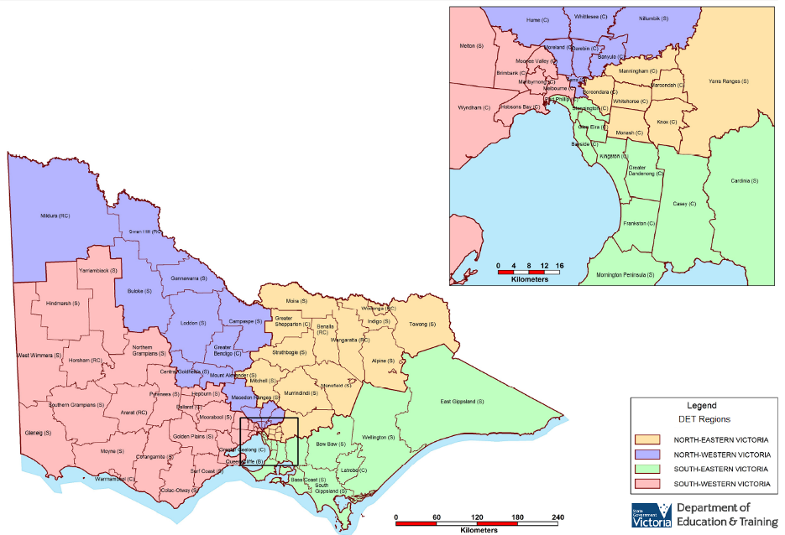

Appendix 2 Fire Districts

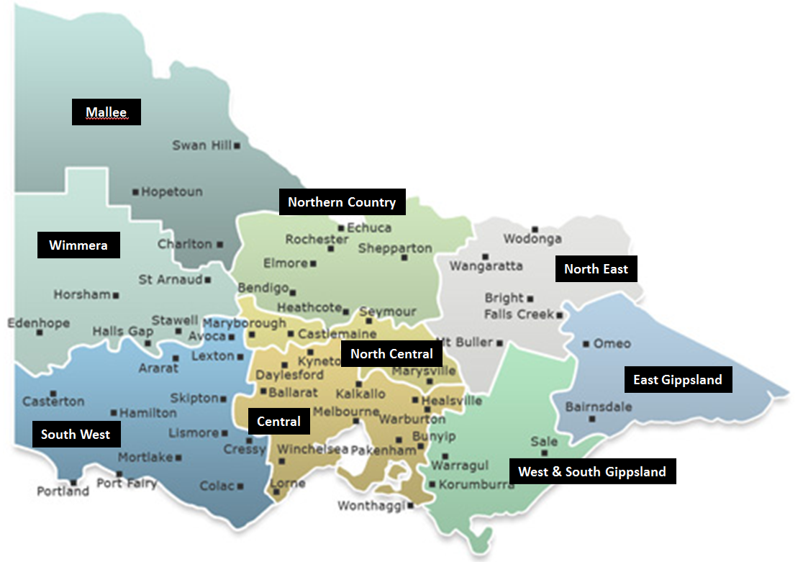

Appendix 3 Emergency Response Drill Observer’s Record
- Drill Address: |  | Location:
Drill Conducted: |  | Drill Date:
Objective of Drill
Observer Name:

Depending on the type of drill conducted, it is recommended you advise emergency services and members of the community who may be affected ahead of the exercise.

Item | Yes | No |  | N/A
Did the designated or replacement Chief Warden/Education Commander take charge?
Was the (simulated) call to emergency services done promptly?
Was the simulated call to SSU done promptly?
Was the (simulated) call to the region done promptly?
Was someone appointed to liaise with the emergency service/s?
Was someone appointed to liaise with the parents/community?
Were instructions given by the Chief Warden/Education Commander followed by children/students, staff, visitors and contractors?
Were floor areas checked / isolated areas searched by Wardens?
Was a roll call conducted for:
Students
Staff
Visitors, contractors and volunteers
People with special needs
Was the Emergency Kit readily available?
Did the Emergency Kit contain all the items listed in the EMP template checklist?
Did anyone re-enter/leave the premises before the “all clear” was given?
Did anyone refuse to leave the building/site?
Was the relevant procedure in our EMP followed?
Was the EMP communication tree followed?

Evacuation Drill Sequence Checklist | Time
 | Hour | Minute
Alarm sounded
Warden/s respond
Wardens check floor/area
Evacuation commenced
Wardens report floor/area clear
All persons accounted for
Arrive at assembly area/safe place
Wardens check all present
Evacuation completed
Exercise terminated

Comments/Issues for follow up by the EMP Planning Team:

Note: Incident Management Team (IMT) operational/outcomes evaluation should be held immediately after each drill; the evaluation should go through the Emergency Drill Observer’s Record and discuss actions to improve procedures, the EMP or address identified issues.

Appendix 4 Post Emergency Record
School Name
Emergency Event
Date and Time of Emergency
Description/Details Of Emergency

Immediate Actions Taken | Chief Warden/Education Commander Notified:  YES / NO Time _____  Other staff Notified:  YES / NO Time _____  Emergency Services Notified:  YES / NO Time ______ | SSU Notified :  YES / NO Time ______  Region Notified:  YES / NO Time ______  IMT Convened:  YES / NO Time ______
Key Actions Taken

Issues | Operational Debriefing Required:  YES / NO Date/Time _____  Person Responsible to Organise:  Confirmation of Operational Debriefing: Date/Time:  Issues for Follow Up Action:
This Record Completed By:
Position Title:
Telephone Number:
Signature and Date:

Verify all details of the incident on receipt of the IRIS incident report forwarded to the school.
For DET’s guidelines on reporting an emergency or incident go to: Reporting emergencies and incidents page.
For non-student related injuries/incidents enter the incident on eduSafe via this link: EduSafe log in page.
For guidelines on incidents that must be notified to the Victorian WorkCover Authority (formerly WorkSafe) go to:
WorkSafe notification page

