INSERT LOGO

Looking after our environment
Together we are learning about why it is important to look after our environment and we are ensuring that we are practicing water and waste minimisation (L.O 2.4, Element 3.2.3)

We turn off our tap when we are finished washing our hands
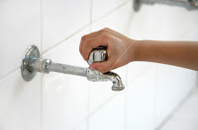
We use one piece of paper towel at a time
