Translate Information into Other Languages
Step 1
Go to https://translate.google.com/

Step 2
Copy information that requires translation into box

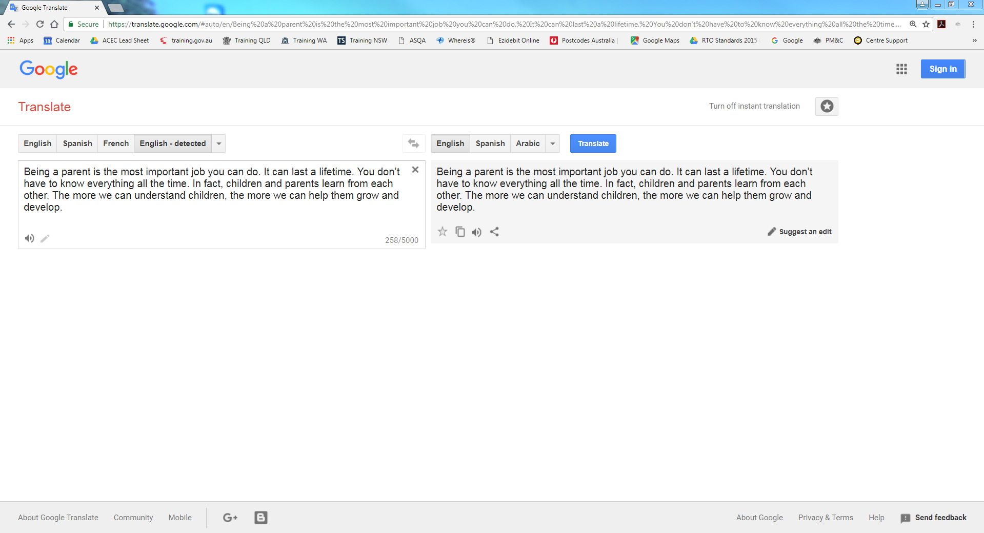

Step 3
Use drop down menus to choose language to translate to and from. The website should automatically translate the information.

Step 4
Copy translated information into a word document. Save and print.

Translating Websites
Step 1
Go to https://translate.google.com/

Step 2
Insert website link you need translated into the box
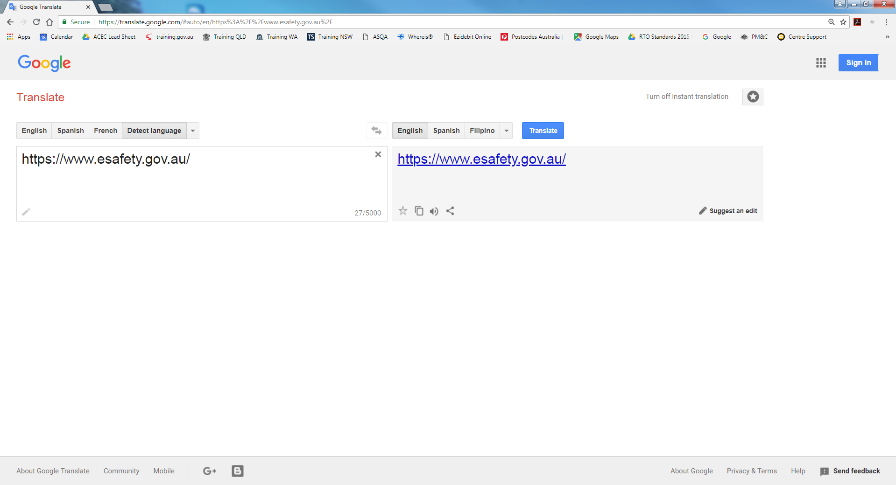

Step 3
Use drop down menus to choose language to translate to and from
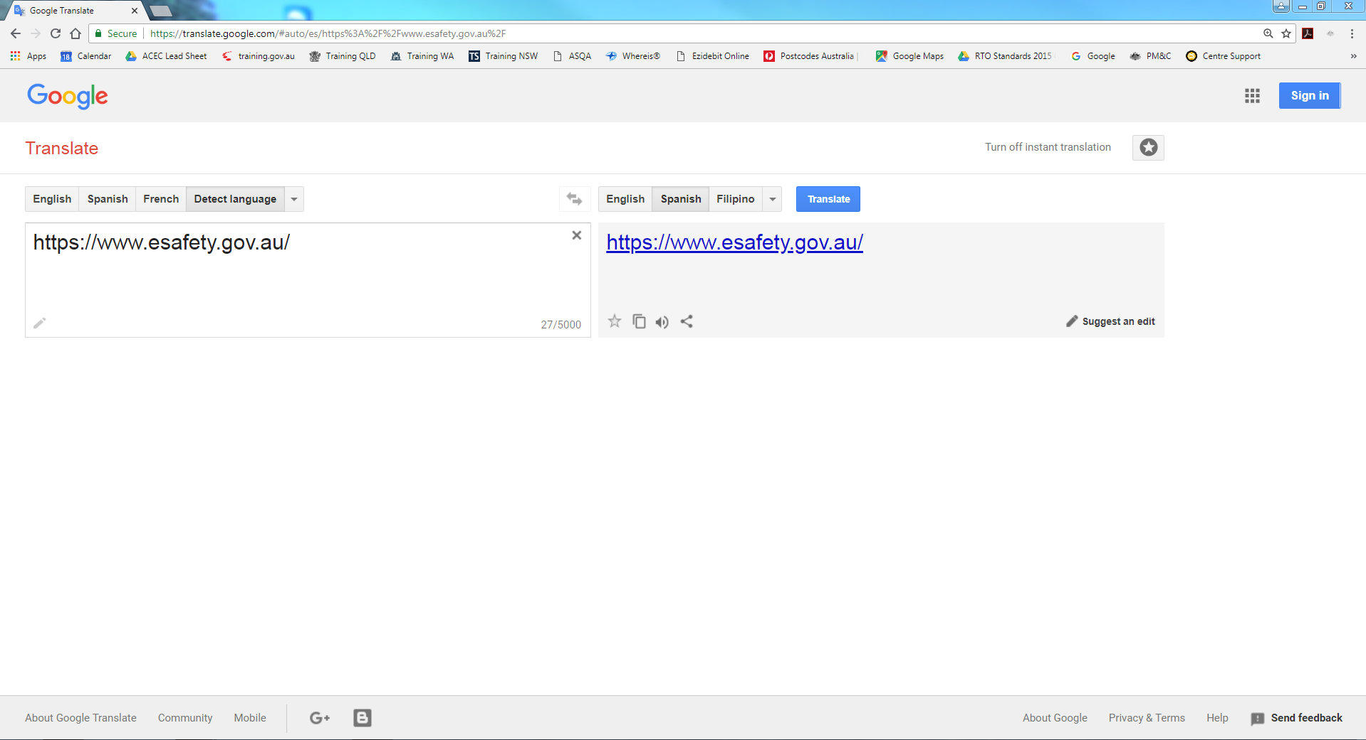

Step 4
Click on website and it will be translated for you. If you need to change the language use the drop down menus at the top.
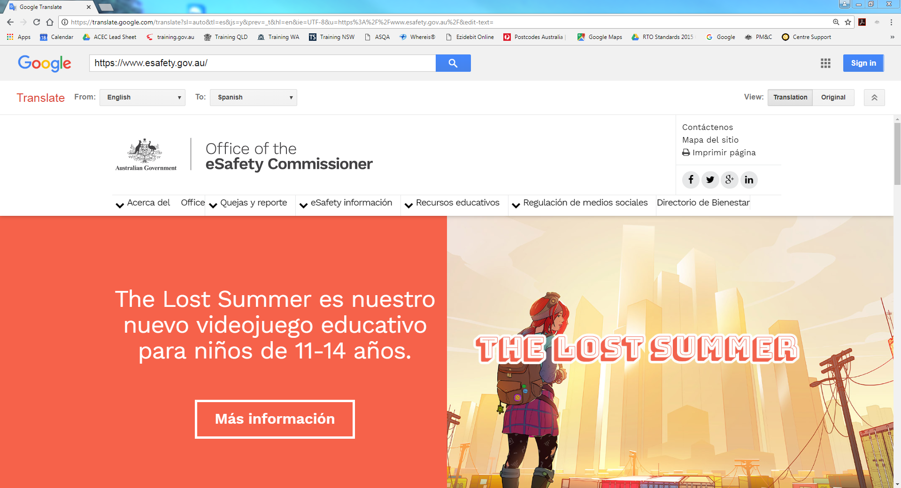

Step 5
If you need to translate a different website, enter it into the box and press the search button


