Risk Assessment and
Management Tool

Minimise the risk of harm while maintaining an enriching learning
and working environment.

© 2021 Australian Children’s Education and Care Quality Authority
Copyright in this resource (including, without limitation, text, images, logos, icons, information, data, documents, pages and images) (“the material”) is owned or licensed by us.
Copyright in material provided by Commonwealth, State or Territory agencies, private individuals or organisations may belong to those agencies, individuals or organisations and be licensed to us. Subject to any contrary statement on relevant material, you may use any of the material in this resource for your personal and non-commercial use or use on behalf of your organisation for non-commercial purposes, provided that an appropriate acknowledgement is made (including by retaining this notice where the whole or any part is reproduced or used without material alteration), and the material is not subjected to derogatory treatment.
Apart from any other use as permitted under the Copyright Act 1968 (Cth), all other rights are reserved.
Requests and enquiries concerning further authorisation should be addressed to:
The Copyright Officer,
ACECQA
PO Box A292,
SYDNEY NSW 1235
or emailed to copyright@acecqa.gov.au.

About the ACECQA Risk Assessment and Management Tool

The Australian Children’s Education and Care Quality Authority (ACECQA) is an independent national authority committed to promoting and fostering continuous quality improvement in approved education and care services, and publishing resources that support the children’s education and care sector in understanding the National Quality Framework.
ACECQA’s vision is for children in Australia to have the best start in life, and nearly 16,000 services across Australia are assessed and rated under the National Quality Standard, delivering quality education and care to over a million children.
The Risk Assessment and Management Tool, developed by ACECQA, aims to help children’s education and care service approved providers, leaders, educators, teachers and staff to understand the importance of assessing and managing risk as an embedded part of quality practice and improvement.
This tool is suitable for:
- Long day care
- Preschool/kindergarten
- Family day care
- Outside school hours care.
The tool can assist in identifying, assessing and managing the risk of harm to anticipate the likelihood and consequence of an incident. Working to reduce the risk of harm will help ensure the health, safety and wellbeing of children, families, staff and community members within your service.
This tool and the templates in it are intended as a starting point. They are designed to be adapted to meet the needs of your service. You are encouraged to adjust the templates to suit the context of your service, when new hazards are identified or as circumstances change.
It is good practice to regularly review service policies, procedures, practices and templates. This will ensure compliance and support the consistent and ongoing practice of identifying hazards and the best strategies to manage risks and potential harm.
Approved providers, service leaders, educators, teachers, coordinators and staff are encouraged to seek out state or territory-specific standards and requirements along with relevant work, health and safety documents to support your service’s risk assessment and management practices.
This tool will support your service to:
- ensure the health, safety and wellbeing of children, families, educators and staff
- identify potential risks and hazards before an incident or accident occurs
- build capacity in conducting both formal and informal risk assessments and management plans
- critically reflect on ways to develop, review and update policies and procedures
- encourage, share and collaborate with children, families and the wider community on risk management
- effectively identify and implement strategies to support self-managed risk through play, improving learning and developmental outcomes for children
- improve the rate of compliance with the Education and Care Services National Law Act 2010 (National Law), and the Education and Care Services National Regulations (National Regulations)
- continually improve service practices aligned with Quality Area 2 of the National Quality Standard (NQS).

Contents

About the ACECQA Risk Assessment and Management Tool 3
Introduction 6
Key terms and explanations 10
Risk management cycle 18
Risk Matrix 20
Completing a risk assessment 23
Excursions 29
Transporting children 32
Activities and reflections to build understanding of risk assessment and management 34
Templates for approved providers, nominated supervisors and family day care educators 45
Learning experiences: templates for children 70
Resources and information 73

Introduction

Acronym list
ACECQA | Australian Children’s Education & Care Quality Authority
NQF | National Quality Framework
NQS | National Quality Standard
EYLF | Belonging, Being and Becoming: The Early Years Learning Framework for Australia
MTOP | My Time, Our Place: Framework for School Age Care in Australia

What are my responsibilities under the National Quality Framework (NQF)?
The NQF includes the:
- National Law and National Regulations
- National Quality Standard
- Assessment and quality rating process
- Approved learning frameworks.
The National Law and National Regulations do not define risk. However, section 167 of the National Law and Part 4.2 of the National Regulations provide requirements regarding children’s health and safety and protection from harm and hazards.
This is the focus of Quality Area 2 of the NQS, aiming to safeguard and promote children’s health, safety and wellbeing while minimising risks and protecting children from harm, injury or infection.
- For information on Quality Area 2: Children’s health and safety, refer to the Guide to the NQF
- For more information on child protection, refer to the relevant legislation in your state or territory
- Regulations 100, 101 and 102 set out the obligation services have in relevant legislative requirements when conducting risk assessments prior to an excursion.
  - Regulations 102B, 102C and 102D set out the legislative requirements regarding the transportation of children other than as part of an excursion.
- For information on excursions and regular excursions, refer to Section 2.13 in the Guide to the NQF.

Why does my service need to complete risk assessments?
Section 167 of the Education and Care Services National Law requires approved providers, nominated supervisors and family day care educators to ensure that every reasonable precaution is taken to protect children being educated and cared for by the service from harm and from any hazard likely to cause injury.
Taking precautions involves completing risk assessments to identify and assess risks, and to plan how to minimise or manage them. Managing risks and hazards should be embedded in daily practice.
Risk can arise:
- through any part of the environment where education and care is provided to children including the physical environment, staff members and other people at the service
- from an action or through a failure to act
- from systemic failures, such as an approved provider not having adequate systems in place to control for risk.
For more information on risks assessments within a workplace, Standards Australia has published The Australian Standard for Risk Management which you can find on their website.

Who is responsible for the process of risk management within my service?
It is the responsibility of everyone working within an education and care service, including approved providers, service leaders, educators, and staff, to manage risks as part of service delivery. The approved provider of the service must ensure that policies and procedures are in place in relation to risk assessments and matters as set out in r168 and r169 of the Education and Care Service National Regulations.
Educators and staff are encouraged to consider opportunities to collaborate with children when making and implementing decisions about risk management. Collaborating with children:
- enables children’s views and opinions to be taken into account, which builds understanding and ownership of policies and procedures
- promotes stimulating learning environments that embed individualised levels of appropriate risk and challenge for all children.

Reflective question
- Think about how children, families and community members are (or could be) involved in the process, and how changes will be communicated to them.

How often does my service need to focus on risk management?
To comply with the National Law, your service should incorporate ongoing risk management practices by:
- completing regular risk management and safety checklists
- regularly updating maintenance logs kept of your premises, equipment and resources
- carefully planning new or risky experiences for children and identifying any emerging risks in play
- engaging in active supervision.
Conducting risk assessments is an ongoing process that occurs when:
- the service environment and practices are reviewed, changed or renovated
- new experiences are introduced
- excursions are planned
- children are transported by the service
- policies and procedures that require risk assessments, such as the emergency and evacuation policy and procedure, are updated
- potential risks are identified
- an accident or serious incident has occurred or a complaint has been received.

Family day care services
Regulation 116 requires approved providers of family day care services to conduct an assessment, including a risk assessment, for each proposed residence and family day care venue of the service, either at the time of application for service approval or before education and care is provided at those residences and venues.
Approved providers are then required to conduct an assessment, including a risk assessment at least annually thereafter to ensure that the health, safety and wellbeing of children who are educated and cared for by the service are protected.
Matters to be considered in the assessment include the matters relating to family day care services in Division 1 of the National Law and regulation 117 as well as the suitability of the residence or venue for the ages and numbers of children attending, the suitability of nappy change arrangements, the existence of water hazards and any risk posed by animals at the service or venue.

Managing risk and the approved learning frameworks
A guiding principle of the NQF is that children are successful, competent and capable learners. The NQF promotes the view of children as capable learners who actively construct their own understandings and contribute to others’ learning. It recognises children’s agency, capacity to initiate and lead learning, and their rights to participate in decisions that affect them, including their learning.
The approved learning frameworks recognise that when children are provided with the opportunity to take considered risks, they develop their sense of identity, social-emotional wellbeing and capacity as confident and involved learners. A ‘considered risk’ is one that has been thought out by the child, and where needed, with the support of an educator or more experienced peer.
Involving children in risk management planning can support children’s developing sense of agency and feeling of control over actions and their consequences. Children who have opportunities to effectively assess and manage risk at an early age will be better equipped to deal with risk as an adult. It also creates a learning environment where children can identify their limits, seek help when needed, and supports children to explore, experiment and cope with the unexpected.
When considering the practice of creating learning environments:
- Belonging, Being and Becoming: The Early Years Learning Framework for Australia (EYLF) states that ‘play spaces in natural environments invite open-ended interactions, spontaneity, risk taking, exploration, discovery and connection with nature’ (EYLF, p. 18).
- My Time, Our Place: Framework for School Age Care in Australia (MTOP) emphasises educators planning environments with appropriate levels of challenge so that children are encouraged to explore, experiment, problem solve and take appropriate risks (MTOP, p. 35).
This tool and associated templates can be used to assist approved providers, service leaders, educators and staff to support the children to be successful, competent and capable learners by seeking opportunities to guide children to assess, manage and take appropriate risks within their play.

Key terms and explanations

A shared understanding of key terms will provide clarity and support a consistent approach to risk assessment and management processes within your service.

Hazard
A hazard refers to a situation or element that could result in an individual getting injured.
Not every hazard will have a harmful outcome. Understanding the likelihood and potential severity of harm is essential in mitigating hazards without unnecessarily restricting risk and challenge from the learning environment. Recognising the possibility and potential severity of harm will help to determine whether the hazard needs to be managed and to what extent.
Examples of possible hazards:
- An open water trough in a play space is a potential hazard if adequate supervision is not maintained.
- A broken piece of equipment that is unstable, unsafe or has sharp edges may be a potential hazard if not repaired, replaced or removed.
- An incident or outbreak of a possible infectious disease may be a hazard if the appropriate infection control measures are not put in place.

Risk
A risk is any situation where the outcome is uncertain, where there is a chance that harm will occur. A risk of harm to someone occurs when a hazard can’t be removed. If a hazard can’t be eliminated, the potential for injury must be minimised and the risk managed on an ongoing basis (SafeWork NSW).
However, taking a risk in play and leisure activities doesn’t always lead to harm and can result in a positive outcome.
It is important to understand that the concept of risk is subjective. How you perceive risk is influenced by your personal beliefs, teaching philosophy, past experiences and view on children’s capabilities and agency, as well as the age and capabilities of the child or children. The unique circumstances of each situation also influence how children interact with risk in the play experiences.

Reflective questions
- Consider, how your concept of risk compares with others within your service?
- How and why might perspectives of risk be different between educators?

Depending on the age and capabilities of the child/children, examples of play situations involving some element of risk could include:
- A child climbing up a tree for the first time. It is uncertain whether the child will reach their goal without injury.
- A group of children playing in mud. It engages their four senses of sight, touch, smell and hearing and also requires the children to be aware of how they move in the mud.
- Using woodwork tools as part of the program.

Risk-benefit analysis
A risk-benefit analysis compares the risk itself with the possible benefits the risk has to children’s learning, development and wellbeing. It is developed in conjunction with the risk assessment.
This is an approach to risk assessment in which risks and benefits are considered alongside each other. It allows approved providers, nominated supervisors, educators and staff to meet their legislative obligations, while promoting a reasonable, balanced approach to play, learning and leisure.
The Child & Nature Alliance of Canada has developed a Risk-Benefit Assessment for outdoor play: A Canadian Toolkit that has a sample of a risk-benefit analysis template that you can adapt to your suit your service context.

Risk assessment
Key Point
Risk management describes the efforts of the whole service to mitigate risks and hazards, while risk assessments are the process by which specific hazards and risks are addressed.

Undertaking a risk assessment means evaluating or deciding which risks are significant and how they should be addressed. Risk assessment is one part of risk management.
It involves critical reflection on the benefits and hazards identified within the service, such as an experience, excursion, practice, piece of equipment or learning environment.
If your assessment highlights a possible risk, this does not mean that the experience or excursion cannot proceed, or that a resource cannot be used. Identifying and prioritising actions and responses as categorised by the level of control required to secure, manage, reduce or eliminate the risks is what is required.
Under the National Law and Regulations, some specific risk assessments must be completed and provided to families, including the risk assessments for excursions or transportation of children. Your service’s policies and procedures may also reference sharing these and other risk assessments with families. While there are no legislative requirements for risk assessments to be displayed at the service, many services do.
Risk assessments must be made available to an authorised officer from your state or territory regulatory authority to sight when requested. The Guide to the NQF will provide you with more information on sharing risk assessments.

Risk management
Risk management is the skill or job of deciding what the risks are in a particular situation and taking action to prevent or reduce them (Collins Dictionary, 2021). It is the overall process of systematically evaluating and managing risks in your service environment or program.
It is important to consider the effectiveness of the service’s risk management processes. This involves considering the way educators and service leaders:
- organise and ensure adequate supervision
- support children in risky play, and assess the benefits of doing so
- are proactive, responsive and flexible in using their professional judgement to minimise injury or harm from occurring.
To ensure the effectiveness of risk management procedures it is also important to develop a range of strategies in line with the NQF. These include:
- developing and following the relevant service policies and procedures including; dealing with medical conditions and infectious diseases, emergency and evacuation and incident, injury, trauma and illness procedures and excursions
- appropriate staff training and administration of first aid
- contacting emergency services or medical professionals
- communication with families and completing and sharing incident notification forms
- maintaining adequate supervision
- managing the emotional wellbeing of children, educators and staff
- meeting legislative notification requirements
- reviewing and evaluating procedures after an incident as part of the quality improvement process.
An example of a strategy for identifying, assessing and managing a risk is as follows:
- After going for a bushwalk, the children asked if they could climb a tree at the service. The educator, keen to address children’s ideas and provide this challenging opportunity for children, conducts a risk assessment. The educator collaborates with the children, families, other educators and service leaders and determines that while the tree would be able to be climbed, the ground underneath the tree needs to be regularly cleared of any hazards, including rocks. This task is added to the daily outdoor safety checklist. The children and educators also come up with the idea of placing a sign on the tree to let the children know when an educator is available to assist and ensure their safety while climbing the tree. The sign is colour-coded and green indicates that an educator is available and the tree can be climbed, and the red sign means that there is no educator available to help and the tree cannot be climbed at that time.

Challenge
A challenge is a task or experience involving a level of difficulty and a possible level of risk. The outcome of a challenge can be uncertain, and for many the goal is to achieve satisfaction from mastering a new skill or activity.
Depending on the age and capabilities of the child, examples of a challenge may include children having goals of:
- cutting a magazine with scissors with the adequate supervision of an educator
- skipping rope after they have observed other children doing it
- learning to walk
- learning to ride a bike without training wheels
- hitting a nail with a hammer
- crawling over a mound or climbing a tree.

Self-managed risk
As children learn to assess and manage risk independently, they are empowered to make informed decisions about risks within their daily lives. This is an essential lifelong skill, as they will encounter increasingly challenging situations and uncertainties within their lives. The process of self-managing risk supports children to develop a range of skills and attributes, including:
- problem-solving
- resilience
- persistence
- confidence
- independence
- an ability to assess hazards and risks.
This is the focus of Standard 3.2 of the NQS in which services have quality learning environments that are inclusive, promote competence, independence and exploration through play.

Adequate supervision
Adequate supervision is a requirement under section 165 of the National Law. The legislation states that the approved provider of a children’s education and care service, the nominated supervisor and the family day care educator must ensure that all children being educated and cared for by the service are adequately supervised at all times that the children are in the care of that service.
This includes during excursions and on transportation provided or arranged by the service.
Educator-to-child ratios alone do not achieve adequate supervision. Supervision is critical to the safety of children and helps to protect children from harm or hazards that may arise in their play and daily routines.
In general terms, adequate supervision helps to protect children from hazards, risks and harm. Adequate supervision ensures that educators and service leaders:
- can respond immediately, including when a child is distressed or in a hazardous situation
- know where all children are at all times
- ensure staff arrangements allow activities and experiences to be actively monitored and supervised appropriate to the age and abilities of the child and the risks involved.
Educators conduct risk assessments and use their professional judgement to determine an approach to the supervision of children. This allows educators to assess and implement the level of supervision required for different situations.
Balancing supervision and engagement in children’s play is a skill that can be enhanced by drawing on a range of strategies, skills and knowledge, for example by thinking about:
- adult positioning within play spaces
- moving throughout the physical environment
- using your peripheral vision
- monitoring changes in children’s noise and stress levels
- knowing each child well, their strengths and abilities and identifying appropriate opportunities for development.
Quality Area 2, Element 2.2.1 – Supervision
Descriptor: At all times, reasonable precautions and adequate supervision ensure children are protected from harm and hazard.

For additional information on adequate supervision see ACECQA’s information sheet Active supervision: Ensuring safety and promoting learning. See also Section 2.1 Adequate Supervision in the Guide to the NQF.
Displaying the following infographic within your service is a useful strategy to support staff in understanding and engaging in adequate supervision practices.
Download, print and share this infographic with educators and staff.
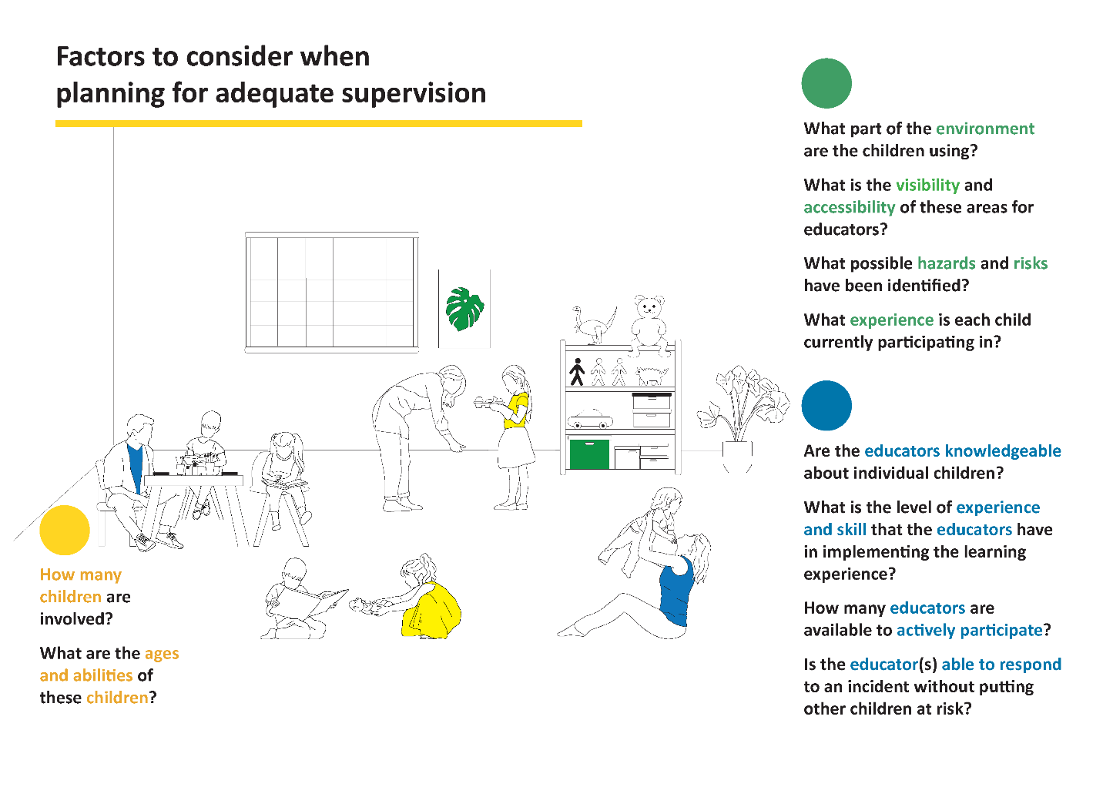
As a general rule, children of different ages and abilities require different levels of supervision. It is expected that educators will adjust the levels of supervision depending on the area of the service and the skills, age mix, dynamics and size of the group of children they are supervising. Younger children will require an adult close by to support, help and nurture them. While older children are developing their autonomy and independence.

Table 1: Considerations when determining the appropriate level of supervision required
Setting | Age | Considerations
Centre-based service  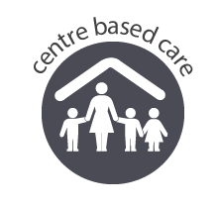 | Birth to three | Educators can see and hear the children at all times, especially when sleeping and eating.  Educators actively supervise experiences, activities and environments.  Supervising educators remain in close proximity to the children.
 | Three year old children | Educators actively supervise experiences and activities and indoor and outdoor environments.
 | Preschool-age children | Educators actively supervise indoor and outdoor environments including when they are being used simultaneously.
 | Over preschool-age children | Educators organise the environment to balance supervision and children’s growing need for privacy and autonomy.  Educators know where each child is and are in a position to respond if necessary.  Educators actively supervise experiences that are identified as higher risk, such as the transition between school and the service.  Educators take into account the different ages and capabilities of each child. Younger children will require closer supervision and support than older children where it is important to balance the need for adequate supervision with respect for their age and developing independence.
Family day care residence or venue  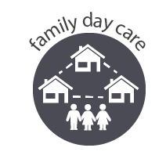 |  | In addition to the considerations above, FDC educators consider how children are adequately supervised when they are in different parts of the residence.  Educators consider the ages and abilities of all children to determine when they require direct supervision.

Key point
Adequate supervision is dependent on the context in that setting at that time, considering the abilities of individual children and the specific features of an environment.

For further information, see Section 2.1 Adequate Supervision in the Guide to the NQF.

Risk management cycle

Introduction
The process of implementing a risk management cycle involves identification of a possible hazard, and determining the risk of potential harm. Answering the following questions can assist in this process:
- How likely is it to happen?
- How often might it happen?
- How serious is the outcome?
- What are the potential benefits and what strategies could be implemented to minimise the risk and maximise the learning outcomes and benefits?
After identifying hazards and assessing the risk of harm, and undertaking a risk-benefit analysis, a risk assessment and management plan should be developed. In managing risks, it is important to consider the potential benefits and treat every scenario as unique.
Risk assessment and management plans minimise the risk of harm while assisting to maintain a stimulating learning environment with appropriate challenges for all children.
Throughout the process of creating risk assessment and management plans, it is important to build in opportunities to consult with children, families, service leaders and community members. This provides an opportunity for all relevant stakeholders to have a voice in the decision-making process.
Consulting with recognised and relevant authorities, including any peak body or sector leader such as Red Nose, SunSmart and Kidsafe Australia, can help inform your service’s risk assessment and management processes. For example, a decision may be made to adjust the timing of an excursion or outdoor learning experiences based on UV radiation safety recommendations.
Key points
It is essential to document the risk assessment and management cycle process.
In some cases, you are required to provide it to families, such as before an excursion is held.
An authorised officer may ask how your service engages with appropriate work health and safety processes and might discuss how your daily practices embed risk management.

The risk assessment and management cycle
The following infographic and descriptions can be used to support the development of your risk assessment and management plans. This will help to identify, assess, manage, evaluate, review, monitor and document the risk of harm to minimise the risk of an incident occurring.
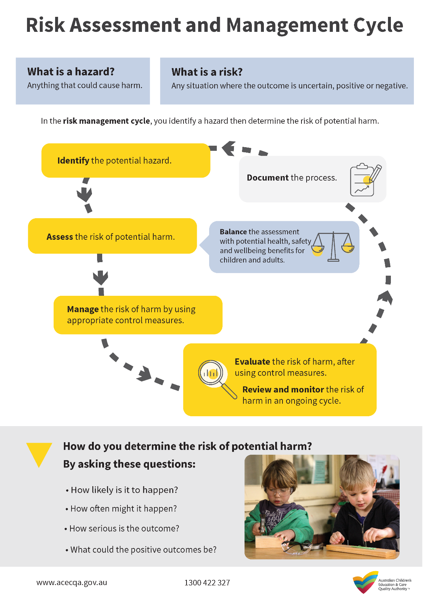
Download, print and share this infographic with educators and staff.

Risk Matrix

A risk matrix is a useful tool to use during the risk assessment process. It helps in identifying the level of risk by looking at the likelihood that a negative event may occur, and the severity of the consequence should it occur.
The Guide to the NQF defines likelihood and consequences in a risk matrix in Section 5: Regulatory Authority power.
Risk Matrix
Consequences | Likelihood
 |  | Rare | Unlikely | Possible | Likely | Almost Certain
 | Major | Moderate | High | High | Critical | Critical
 | Significant | Moderate | Moderate | High | High | Critical
 | Moderate | Low | Moderate | Moderate | High | High
 | Minor | Very low | Low | Moderate | Moderate | Moderate
 | Insignificant | Very low | Very low | Low | Moderate | Moderate

Likelihood
The risk matrix includes five levels of likelihood:
- Rare
- Unlikely
- Possible
- Likely
- Almost Certain.
When thinking about likelihood, the approved provider and service leaders should prioritise actions based on ensuring compliance with the minimum legislative standards, particularly those standards relating to the safety, health and wellbeing of children. The following table is a useful guide.
Likelihood | Description
Rare | Very unlikely – the event may occur only in exceptional circumstances
Unlikely | Improbable – the event is not likely to occur in normal circumstances
Possible | Potential – the event could occur at some time
Likely | Probable – the event will probably occur in most circumstances
Almost certain | Very likely – the event is expected to occur in most circumstances

Consequence
The risk matrix also includes five levels of consequences:
- Insignificant
- Minor
- Moderate
- Significant
- Major.
This takes into account the potential impact of an event and how it might affect the safety and wellbeing of children, families, staff and the wider community.
When analysing the consequences of a potential event occurring, it is important to consider the vulnerability of individuals who might be affected. For example, very young children or children with a disability may be particularly vulnerable as they are less able to act to protect their safety, health and wellbeing.

Risk prioritisation
A risk matrix helps work out the priority of a particular risk. This can help approved providers, coordinators, service leaders, educators and staff to determine which risks to prioritise and address.
Once your service has taken action to reduce, mitigate or eliminate the risk, it is important to reassess the level of risk to children, educators, staff, families and community members to understand the extent to which any action you have taken has reduced, mitigated or eliminated the risk. If the risk is still moderate or more significant, further actions need to be considered.
When assessing risk in play, the NQF states that:
Physical activity enhances brain development, coordination and social and motor skills and helps children to build confidence in their own abilities, develop their independence, and enjoy being active. The educational leader and educators foster physical and psychological development in children by encouraging physical activity that is challenging, extends thinking and offers opportunities to take manageable risks. Instead of trying to eliminate all risk from children’s play, it is important to understand that risky play can be acceptable where the benefit to children’s learning outweighs the risks. Risks can be managed through conducting risk assessments, and weighing the obligation to protect children from foreseeable risk of harm against the benefit of providing children with a stimulating play environment.
(Guide to the National Quality Framework, page 158).

Reflective question
- How do educators plan learning environments with appropriate levels of challenge, where children are encouraged to explore, experiment and take appropriate risks in their learning?

Completing a Risk Assessment

Step 1: Identify
The first step in completing a risk assessment is to identify the hazards and risks within your service. Be vigilant in monitoring your environment. If something that may be dangerous now or in the future is observed or identified, move to step 2 and document the possible hazard or risk.
Identifying hazards and risks can be done by:
- completing daily hazard minimisation checklists
- making hazard identification a regular topic at team meetings
- proactively monitoring learning environments and equipment.
There are potentially many types of hazards within children’s education and care service. This table highlights some of the common examples.
Table 2: Examples of hazards
Type of hazard | Examples of hazards (this list may not include all hazards at your service)
Biological | - Bodily fluids  - Blood  - Faeces, vomit or urine  - Discharge from the nose, eyes or ears  - Sewage  - Stinging insects  - Harmful plants  - Animal or bird droppings  - Mould or fungi  - Infectious diseases  - See relevant factsheets from Staying healthy: Preventing infectious disease in early childhood education and care services (5th Edition)  - Food  - Food handling  - Preparing food  - Preparing, storing and heating bottles  - Children’s cooking experiences  - Medical  - Allergies  - Anaphylaxis  - Medication dosage
Chemical | - Non-hazardous chemicals  - Any liquid, solid or gas that does not pose a risk to children  - Eco-friendly dishwashing liquid  - Hazardous chemicals or products  - Any product that has ‘keep out of reach of children’ or first aid instructions on the label
Critical incident | - A lockdown/lockout  - An evacuation – due to fire, flood, structural damage, or other reasons  - An accident – involving anyone at the service  - Any time an emergency service is required to attend the service
Energy systems | - Electricity  - LP Gas (Liquefied petroleum)  - Gas and pressurised containers  - Water systems – water tanks, flooding indoors, lack of water etc.
Environmental | - Sun exposure  - Water  - Sound and noise  - Animals and insects  - Plants  - Weather conditions and events  - Temperature  - Extreme pollution – eg, from bushfire smoke
Facilities, building environment and equipment | - Buildings and fixtures  - Driveways, car parks or paths  - Fixed equipment  - Furniture  - Non-fixed equipment  - Play and learning resources
Vehicles, machinery and equipment | - Cars  - Buses, trains and trams  - Excavator  - Hand tools  - Kitchen equipment
Manual tasks | - Manual handling of equipment  - Lifting children
Socio-emotional | - Transitions to and from the school or service, between rooms or play spaces  - Social interactions  - Conflict or bullying  - Changes in a child’s family structure eg, the arrival of a new baby or the separation of parents  - Experience of death or other loss
People | - Inadequate staffing  - Visitors  - Guests  - Inconsistent staffing arrangements  - Behaviours displayed by staff, children and families

There may be times when people can pose a risk. Processes need to be in place to ensure visitors, contractors, staff and others are not a potential risk to the safety, health and welfare of children and others at the service. There may also be times when the behaviours of families or children put themselves or others at risk.
Questions to help identify hazards within your service
- What processes are in place to ensure you have undertaken comprehensive assessments to identify any of the hazards in Table 2?
- What hazards were identified within your service and where has this been documented?
- What policies, procedures, risk assessments and management plans are currently in place to manage any hazards?
- Do all employees know about these policies and procedures? How are they informed when policies are reviewed and updated?
- What policies, procedures or risk assessments might need to be updated to address the identified hazards?

Step 2: Assess
After identifying the hazards and risks that exist at your service the next step is to assess the risk of possible harm to children, staff and others. Use the risk matrix on page 20 to:
- assess the hazard
- assess the possible harm, likelihood, consequence and seriousness of the hazard
- identify any potential risks or benefits of undertaking the activity/experience for children’s learning, development and wellbeing.
Document your assessment of the risk of possible harm.
When assessing the risk of possible harm, it is important to consider the following:
- How likely is it to happen?
- How often might it happen?
- How serious is the outcome?
- What are the possible consequences?
- Are there any potential benefits to children’s learning, development and wellbeing?

Following documentation of the hazard assessment, move to step 3.

Step 3: Manage
In step 2, the likelihood, consequences, seriousness and possible benefits of the identified hazards and risks were identified and documented.
The next step is to identify and introduce an appropriate level of control measures within your service to manage the risk or hazard. Control measures are strategies and actions to be implemented to manage, eliminate or reduce hazards and potential risks. Control measures significantly reduce the likelihood of the hazard or risk causing harm.
The following table describes the three levels of control measures and includes examples relevant to a children’s education and care service.

Table 3: Examples of control measures
Hierarchy of control |  | Examples of control measures
Level 1  (Most effective control measure) | Elimination | - Remove the hazard  - Broken toy or damaged resources to be disposed of  - Change the practice  - Request food delivery to be taken directly to the kitchen to eliminate manual handling of bulky deliveries to the kitchen by educators
Level 2 | Isolation | - Separate unwell children from others  - Barricade off a wet floor until dry to avoid slipping hazards, display a ‘wet floor’ sign
 | Engineering | - Use ergonomic cots with a higher base height to reduce manual handling and back injuries for educators  - Provide adult-sized chairs for educators
Level 3  (Least effective control measure) | Administrative | - Rotate educators between different tasks to avoid repetitive strain  - Arrange workflows to avoid peak physical and mental demands towards the end of a shift
 | Personal protective equipment | - Use gloves while changing a nappy or when cleaning bodily fluids  - Wear closed-in shoes to avoid injury  - Wear hats and sunscreen outside

Definition: Level 3 control measures are considered least effective as they rely on consistent implementation by educators and staff. The regular reviews of policies, procedures and daily practices will embed the control measures you have developed and put in place at your service.

Step 4: Evaluate and monitor
After introducing the most appropriate control measure in step 3, it is now time to evaluate and monitor the risk of harm. Document your evaluations for each part.
Evaluate the risk of harm using the risk matrix on page 20:
- Is the likelihood and consequence of the risk of harm now reduced?
Evaluate the current risk or potential harm by documenting responses to the question:
- How well is the risk of harm managed or eliminated?
If the risk of harm is still high, then ask:
- What alternative control measures can be introduced?
- Is this the best possible outcome?
It is crucial to monitor and evaluate the risk of harm regularly. This will ensure that the risk of harm continues to be managed as low risk. The approved provider, service leaders, coordinators, educators and staff should be vigilant in scanning and assessing the risk of harm within the service. In practice this may include:
- completing and documenting daily safety checklists
- conducting regular work, health and safety inspections
- making the risk management assessment cycle an agenda item for each staff/team meeting.

Excursions

Experiences outside of the service have many benefits for children’s learning, development and wellbeing. Excursions are a way to encourage children to become active members within their community. Given the opportunity to observe and explore, children are able to integrate new concepts within their play. Through this play, children are able to comprehend how the wider community influences their role within it.
Your service must have policies and procedures in place for excursions. This is a requirement under regulation 168 of the National Regulations. Your excursions policy and procedures should reference regulations 100-102. Regulation 100 states that the approved provider of a children’s education and care service and a nominated supervisor and family day care educator must ensure a risk assessment is carried out in accordance with regulation 101, before an authorisation to take the child on the excursion, referred to in regulation 102(4), is sought.

What should an excursion risk assessment consider?
In compliance with regulation 102 an excursion risk assessment must identify and minimise any factors which may pose a risk to the safety, health or wellbeing of a child. Your assessment should include:
- the proposed route and destination for the excursion
- any water hazards and risks associated with water-based experiences
- transporting children, including:
- the means of transport
- seatbelt requirements for your state or territory
- the process for entering and exiting your service’s premises
- the pick-up location or destination (as required)
- procedures for embarking and disembarking the means of transport
- a description of how each child will be accounted for on embarking and disembarking the means of transport.
- the number of adults and children involved in the excursion
- the number of educators or other responsible adults needed to provide adequate supervision
- the proposed experiences
- the length of time for the excursion.

Educator-to-child ratios during an excursion
Regulation 123 states that ratio requirements that apply within the service remain the same while on an excursion. Under the National Law and Regulations, there are no specific excursion ratios. Your risk assessment should determine whether minimum staff to child ratios will suffice or higher ratios are required to ensure adequate supervision at all times.

The requirements of a regular excursion
A regular excursion might include walks, drives or trips to and from the service:
- that the service regularly visits as part of its educational program
- where the circumstances relevant to the risk assessment are the same on each outing.
Regular excursions require at least one risk assessment to be completed within 12 months. This also applies to seeking authorisation from a parent or other authorised individual for a child to leave the service on the excursion. It is up to your service how and when they notify families and carers about attending these regular excursions.
As per regulation 102 the authorisation for an excursion must state the following:
- the child’s name
- the reason the child is to be taken outside the service premises
- the date the child is to be taken on the excursion and the time that the child will be away from the service
- unless it is for a regular excursion
- a description of the proposed destination and activities to be undertaken by the child for the excursion
- details about transporting children:
- the means of transport to be used
- any state or territory specific laws for seatbelts or safety restraints
- the anticipated number of children likely to be attending the excursion
- the expected educator-to-child ratio and the number of staff members and any other adults who will accompany and supervise the children on the excursion
- that a risk assessment has been prepared and is available at the service, noting that:
- where a children’s education and care service is provided on a school site, it is not considered an excursion if the child or children leave the service accompanied by an educator but do not leave the school site.
For example, if a preschool group visits the library within their school site, it is not considered an excursion or regular excursion.
The National Law and Regulations do not state how much notice families and carers must be given before an excursion occurs. Consulting with families and carers and critically reflecting on your policies and procedures will assist in determining the appropriate notice periods for regular excursions.
Key points
For further information go to Section 4, part 2.13: Excursions in the Guide to the NQF.

Transporting children

Adequate precautions need to be implemented to protect children from any harm and hazard and you must consider the safety, health and wellbeing of all children. Transportation presents additional risks to children as a result of the mode and method of transport. This includes the period of transition from a vehicle to a children’s education and care service premises or the destination. These risks apply to single trips or during periods of regular transportation, for example when a family day care educator is collecting school age children from school.
Regular transportation, in relation to a children’s education and care service, means the transportation by the service or arranged by the service (other than as part of an excursion) of a child being educated and cared for by the service, where the circumstances relevant to a risk assessment are substantially the same for each occasion on which the child is transported.
If a service transports children to multiple locations during their attendance, then regular transportation can refer to each venue and location that remains the same each week. This means, that for example, if a service takes children to a tennis court every Monday for their sport activity, then the service completes a regular transportation risk assessment and relevant procedure for the tennis court location. A separate risk assessment should be done for each of the venues, locations and days, whose circumstances remain substantially the same week to week.
Under the National Law, services are required to take into account the levels of supervision and ratios of staff and children. It is important to verify the number of children being transported at different points of the journey. Risk assessment and management strategies should include head counts, in particular when children are embarking or disembarking from the means of transport.

Road and seatbelt safety
Approved providers, nominated supervisors and family day care educators should have regard to the state and territory laws and requirements that might apply to modes of transport, seatbelt requirements and licencing of drivers. For example:
- Road safety rules
- Driver training requirements
- Any working with children check requirements.
School age children must wear correctly fitted and adjusted seatbelts or restraints. School age children should be in the most appropriate restraint until they reach the maximum size limit (height/ weight). If the child is over 7 years of age and still fits in a child car restraint then you are required to keep using it.
For children under school age, the approved provider, nominated supervisor and family day care educator must ensure that the child is securely fastened in the correct child seat for their height and age. The car seat must meet Australian/New Zealand Standard AS/NZS 1754 and be correctly fitted into the back seat of a car.
For more information on your legal responsibilities, contact your state or territory government department responsible for road safety.
For more information about keeping children safe when travelling contact Kidsafe, the Child Accident Prevention Foundation of Australia.

Safe transportation of children – other than during an excursion
If your service transports, or arranges transportation of children, other than as part of an excursion, the service is required to have an additional policy and procedure in place relating to that transportation. These should include procedures for complying with relevant provisions on authorisations and risk assessments for transporting children. For example, if your service collects children from their home and transports them to the education and care service.

Safe transportation of children as part of an excursion
A service’s policy and procedures on excursions must address transportation requirements relating to excursions, which are different from the requirements for transportation other than as part of an excursion. Your service should carefully examine the National Regulations to ensure that all relevant requirements are clearly addressed and complied with.
For more information go to:
- the National Regulations 168(2)(ga), 102(B), 102(C), 102(D) and 99
- Section 2.14 – Transportation of the Guide to the NQF
- ACECQA’s Information Sheet: Safe Transportation of Children
- ACECQA Transportation FAQs page.

Activities and reflections to build understanding of risk
assessment and management

The following reflective questions and activities are designed to help embed the concepts of risk assessment and risk management into your service’s practices.
You might like to think about incorporating these questions and activities into your team meetings or educator home visits.
To include the voices of children, families and community members, consider sharing or displaying these reflective questions in play areas and family spaces and during children and family meetings, and invite their valuable input.
There is a set of reflective questions or an activity for each Quality Area of the NQS. They can be used by an individual or with a team. The reflective questions and activities can be adapted for use within other quality areas, and we encourage you to adapt them to suit your unique service context.
Documenting the responses can add value to your Quality Improvement Plan (QIP) and discussions with the approved provider, service leaders, coordinators and an authorised officer during compliance, monitoring and assessment and rating visits.

Quality Area 1: Educational program and practice
For each key term, brainstorm learning experiences that will build children’s knowledge and understanding of them. For infants and young children, brainstorm learning experiences that can include the actions associated with these key terms. For example, an action of the key term hazard might be showing young children how to hold the scissors correctly.
Hazard

Risk

Challenge

Risk management

Risk assessment

Risk-benefit analysis

Self-managed risk

Adequate supervision

Quality Area 2: Children’s health and safety
Reflect on the supervision practices being followed at your service. Answer the following questions.
What supervision strategies exist to manage the risk of harm to staff, children, families and community members who enter the service? How do we know they are adequate to ensure each child’s health, safety and wellbeing?
Where should educators be positioned in the environment to ensure they are providing support to children during play?
Which of our current supervision strategies support the development of children’s agency and emerging autonomy in play, leisure and decision making?
How do educators encourage children of different ages to consider the potential risk of harm in their play? For example, do we use targeted questioning, modelling and narration of children’s play?
How do we plan learning experiences to suit individual children’s opportunities for risk within their play? What strategies do we use to learn about each child’s participation in risky or challenging play? For example, some children may be excited and ambitious, while others may be frightened and unwilling to participate in the experience.

Quality Area 3: Physical environment
Use the words to fill in the blanks in the following scenarios:
You _______ a broken tricycle as the children begin playing outdoors. Straight away you quickly ______ the tricycle and determine that it now poses a risk to the children’s safety. You ______ the risk by taking the tricycle away and therefore ______ the risk. Your ______ is that the hazard must be removed immediately as children are playing nearby. You will consider repairing or replacing the tricycle at a later time, and your _______ of risk management strategies for outdoor play will be done as soon as possible.
review eliminate manage evaluation assess observe
You have been asked to organise and complete a review of the excursion risk assessment as the current version will expire in a few weeks. After walking the excursion route to the park, you _______ that there is no footpath once you cross the road to the park. When you _______ this hazard using the risk matrix, you have identified this as a high risk. You _______ the high risk by identifying, planning and implementing appropriate _________ of increasing the staff to child ratio, finding an alternate route to the park and setting out clear expectations around behaviour for children before the excursion begins. You then _______ the risk as being acceptable after using the risk matrix again. During the excursion the risk and control measures were ________ for future excursions.
control measures monitored identify assess manage evaluate
You have _________ the potential risk of back injury when educators lift young children onto the nappy change table. You _________ this practice as a high risk due to the frequency and possible significant _________ to an employee’s health and safety. At a team meeting it was discussed that nappy changing cannot be _________ but can be _________ with:
- Educators undertaking manual handling training
- Educators sharing the nappy changing routine throughout the day
- The installation of a step ladder for children to use, which will reduce the amount of lifting being done each day.
Upon _________ these practices have reduced the risk of possible injury to educators. Regular _________ will ensure the control measures are applied consistently.
identified monitoring consequences review evaluation managed assess eliminated
Note: The answers to this activity can be found on page 43.

Quality Area 4: Staffing arrangements
Reflect on the current staff retention practices being followed at your service and answer the following questions.
Document and critically reflect on how your services current practices promotes the consistency of educators.
What are the possible risks and negative consequences for children, families and educators associated with not having strategies for the consistency of educators?
What is the likelihood that these negative consequences will occur?

Quality Area 5: Relationships with children
Use this scenario at a team meeting to unpack the risk assessment management benefits in building relationships between children and children and educators.
Scenario: For one child, participating in a structured, whole group experience causes them significant stress. An educator has documented that the child appears to be reluctant to join in and occasionally has difficulty in self-regulating their behaviour during this time.
What are the possible risks associated with in this scenario for the child and others?
What are the potential negative consequences?
What is the likelihood that these negative consequences will occur?
Brainstorm different strategies that could support this child to participate in future whole group experiences.

You can write your own scenarios and use the same questions to continue learning about the benefits of managing risks in the other Quality Areas. Change the last question to suit your scenario.

Quality Area 6: Collaborative partnerships with families and communities
Use this activity to develop and complete a risk management cycle plan for this quality improvement scenario.
After finishing a self-assessment and a review of the Quality Improvement Plan, it has been decided that the service will focus on engaging and building a meaningful relationship with the local community.
Identify the possible risks of harm to staff, children and community members when developing strategies to build these relationships.
Assess the possible risk of harm (using the risk matrix) if these identified risks are not managed.
Complete a risk-benefit analysis by comparing the possible risks with the benefits of developing these meaningful relationships with the community for children’s learning, development and wellbeing
Develop strategies to manage this possible risk of harm (using control measures).
Identify the strategies that will be used to evaluate and review the identified risks of harm.

Quality Area 7: Governance and Leadership
Reflect on the current governance practices being implemented at your service and answer the following questions.
Review your service’s excursion and transport policies and procedures. Do the policies, procedures and permission forms reflect the risk assessment and management cycle and include key terms?
Excursion policy: Yes/No
Transport policy: Yes/No
Permission forms: Yes/No
If you answered no, what strategies will support the process of reviewing and updating these policies and procedures?
A philosophy statement should guide all aspects of your service’s operations. What are the potential consequences if the practices of educators and staff do not align with the intention of your philosophy?
Review each of the role/job descriptions at your service. Identify how effectively they define each person’s role and responsibilities. Identify how they support effective decision-making by educators and the operation of the service.
Document what the consequences are of educators and staff not understanding their roles and responsibilities?
Brainstorm the different ways your service promotes the health, safety and wellbeing of educators and staff in regards to managing risks such as lifting children, or using kitchen equipment.
Brainstorm ideas and some additional strategies that individuals, teams and service management can implement to promote and support the health, safety and wellbeing of staff and educators at the service.

Answers: Quality Area 3: Physical environment

- You observe a broken tricycle as the children are playing outdoors. On the spot, you quickly assess the tricycle and determine that it is now a risk to the children. You manage the risk by taking the tricycle away and eliminating the risk. Your evaluation is that the hazard must be removed. You will look at repairing or replacing the tricycle, and your review will take place when this happens.

- You have been asked to organise and complete an excursion risk assessment as the current version will expire in a few weeks. You have identified that there is no footpath once you cross the road to the park. When you assessed this hazard using a risk matrix, you have identified this as high risk. You managed the high risk by identifying appropriate control measures of increasing the ratios, finding an alternate route and setting out clear expectations around behaviour for children. You then evaluated the risk as being acceptable after using the risk matrix again. During the excursion the risk was monitored for future excursions.

- You have identified the potential risk of back injury when educators lift young children onto the nappy change table. You assess this practice as a high risk due to the frequency and possible significant consequences to an employee’s health and safety. At a team meeting it was discussed that nappy changing cannot be eliminated but can be managed with:
- Educators undertaking manual handling training
- Educators sharing the nappy changing routine throughout the day
- The installation of a step ladder for children to use, which will reduce the amount of lifting being done each day.
Upon review these practices has reduced the risk of possible injury to educators. Regular monitoring will ensure the control measures are applied consistently.

Templates for approved providers, nominated
supervisors and family day care educators

Download, print and share these templates with your educators and staff.

Daily risk management tools
Developing risk management plans is an ongoing part of practice for all children’s education and care services. One way to support this practice is by regularly using a checklist for hazard identification or templates for planned experiences involving new equipment or resources. This can help your service to identify, assess and manage the risk of harm before an incident occurs.
To ensure that these tools remain updated and appropriate for your service context, schedule regular reviews to ensure that hazards are identified, and risks managed before they cause harm.
To begin using these tools within your service, inspect the environment as a team (or as an individual if you are a family day care educator), in consultation with service leaders, coordinators, and/or the approved provider. This will help determine which hazards are the priority or need to be monitored more regularly.
An inspection of your service will assist in adapting the tools to be relevant for your unique service context. Consulting with your children, community, families, educators and staff has the potential to build knowledge, understanding, ownership and a shared responsibility to use these tools. Embedding use of these tools as part of the service’s risk assessment and management practices is important to maintain the focus on assessing and managing risk.
Remember, sometimes a hazard will be identified, which may require a formal risk assessment to be undertaken. However, at other times your professional judgement will determine the need to take immediate action and then document the actions taken to manage the risk at a later time.
The following example demonstrates the use of the tool.
Example of practice
- If poisonous fungus has been found in the outdoor environment, this would require that the established practices and policies be followed and the fungus immediately removed and disposed of, before documenting the actions taken.
- An evaluation and review of the risk assessment and management practices would assist in identifying if anything could be done differently.
- Advice from experts in poisonous plants is essential in informing decision making.
- Through this reflection, it may be decided, for example, to implement strategies to prevent the growth of similar fungi in children’s play areas or that the fungus should first be isolated rather than removed. It may be determined necessary to use gloves to transfer the fungus into a sealed jar, discussed with children to build their knowledge and skills to safely identify, inform others, record the hazard and manage the risk. A range of strategies may be required, considering the age and abilities of the children attending the service.
Policies and procedures must be in place and should reflect the arrangements for transporting children. This is a requirement under regulation 168 and should inform your excursion risk assessment management plan.

As the example above shows, children can be part of the risk assessment and management process. This will support the development of their risk assessment skills as they take increasing responsibility for their health, safety and wellbeing. This has the potential to contribute to Outcome 2 and 3 of the EYLF and MTOP.

Control Measures
This template is a useful tool to identify the existing control measures to manage risks at the service or FDC residence/venue. You can also use this template to brainstorm new control measures that are suitable for your service or FDC residence/venue when new employees begin or a serious incident occurs. This will ensure that all educators and staff understand the significance of reducing (and in some cases eliminating) the likelihood of incidents occurring.
Table 4: Identifying existing control measures
Hierarchy of control |  | Examples of control measures
Level 1  (Most effective control measure) | Elimination
Level 2 | Isolation
 | Engineering
Level 3  (Least effective control measure) | Administrative
 | Personal protective equipment

Possible examples of hazards for consideration
While all services are encouraged to identify if the location of their service presents unique hazards, there may be some hazards that are particularly relevant to a service type or age group that need to be considered.
Example of practice
For a service educating and caring for infants consider:
- The seating for the children - is it appropriate for their age and abilities (this may include checking that safety harnesses are clean and in good working order).
- Are cots in good repair, free of loose bedding, positioned safely and reflective of the recommendations outlined in the Red Nose Safe Sleeping Guide?
For a service educating and caring for school age children consider:
- The systems in place to ensure children’s safety during transitions including drop off and pick up times between home and the service and the service and the school.
For a family day care service consider:
- The risk management strategies in place to manage unexpected visitors (for example tradespeople) to the residence which ensure children’s continued safety and wellbeing.

ACECQA has developed a series of risk assessment and management templates that you can add to and adapt to suit the individual circumstances and unique context of your service.
- Indoor learning environment safety – Daily checklist
- Outdoor learning environment safety – Daily checklist
- Risk assessment and management learning experience plan – Educators/Teachers
- Risk assessment and management template – Excursions
- Risk assessment and management template – Transporting children (other than as part of an excursion)

Key point
- These tools and templates are not exhaustive and are intended to be used as a guide only.
- They should be adapted to meet the individual needs of your service.
- They are living documents which should also be amended when circumstances change and new or potential hazards are identified within the service context.

Indoor learning environment safety – Daily checklist:
Following the daily check, staff are to initial each item and sign the document. Record any actions taken immediately or those that require follow up action. You will also find the Indoor learning environment safety template on the ACECQA website.

Indoor learning environment safety – Daily checklist
Week beginning: ______________
NQS Element | Hazard identification and Risk management | M | Tu | W | Th | F | Action required
 |  |  |  |  |  |  | Immediate | Follow up
2.2 | Hazards from human activity have been managed (e.g. broken glass, rubbish or dirt).
2.2 | Hazards from the natural environment have been managed (e.g. animal waste, spider webs, insect remains).
2.2 | All doors and gates are closed securely and locked where appropriate.  Note - fire exits should not be locked.
3.1 | All facilities, materials and equipment are in good repair and are appropriate for the age group of children.
2.2 | Hazards from electrical outlets and cords have been managed.
2.2 | Chemical hazards have been managed through secured cupboards and signage where appropriate.
2.2 | Trip and slip hazards have been managed  (e.g. loose equipment or loose tiles, damaged mats/rugs).
2.1 | Rubbish bins are clean and ready for use.
2.1.2  2.2.2 | Forms for accident/injury/illness, medication and asthma or anaphylaxis management are stocked, up to date, filed and displayed where appropriate.
To add more rows press TAB.
Staff full name and signatures
Monday: | Tuesday: | Wednesday: | Thursday: | Friday:

Outdoor learning environment safety – Daily checklist
Following the daily check, staff are to initial each item and sign the document. Record any actions taken immediately or those that require follow up action. You will also find the Outdoor learning environment safety – Daily checklist on the ACECQA website.

Outdoor learning environment safety – Daily checklist
Week beginning: _________________
NQS Element | Hazard identification and risk management | M | Tu | W | Th | F | Action required
 |  |  |  |  |  |  | Immediate | Follow up
2.2 | Hazards from human activity have been managed (e.g. broken glass, rubbish, cigarette smoke).
2.2 | Hazards from the natural environment have been managed (e.g. insects, animal waste, hazardous plants, pooling water).
2.1.2 | Weather conditions have been checked and practices for the day adjusted where appropriate.
2.2 | Equipment and play areas (such as gardens, fixed swing structures and sandpits) are clear of rubbish, waste and excess debris (raked as appropriate).
3.1.2 | Movable outdoor equipment is in good working order and positioned according to the relevant regulations and/or national standards.
2.2 | Trip and slip hazards on walkways have been managed (e.g. leaf litter, loose equipment or raised concrete).
2.1 | Bathrooms and handwashing facilities are accessible from the outdoor environment. Facilities are clean, well-stocked and in good working order.
2.1 | Fresh drinking water is accessible from, or in, the outdoor environment.
To add more rows press TAB.

Staff full name and signature
Monday: | Tuesday: | Wednesday: | Thursday: | Friday:

Risk assessment and management learning experience plan – Educators/Teachers
This tool will support your thinking around hazard identification and risk management when planning experiences for children. Use this tool to take all reasonable precautions to identify, assess and manage the risk of harm before implementing the experience and before an incident occurs.
Use the risk matrix and control measure resources on page 20 to help you complete this tool.
It is important to adapt this tool to fit each learning experience so that it is a meaningful part of practice. You will also find the Risk assessment and management learning experience plan on the ACECQA website.
Risk assessment and management – Learning experience plan
Experience name: |  | Date: | Time:
Overview of the experience – Provide a brief overview of the experience

Rationale and links to children’s outcomes – What value does this experience have for the child(ren)’s learning and development?

Who will be participating? – In assessing and managing risk, consider the number of children and your knowledge of their capabilities and dispositions.
Where will the experience occur? – Considerations include adequate space, ventilation, weather and environmental conditions.
What will the children be doing? – Include detail about the experience. |  | What equipment will they be using? – Consider the equipment and materials required. Are there any safe handling procedures needed?
Who will be leading the experience? – Consider whether expertise is required for handling materials or if additional educators might be necessary.

Identify hazards – What are the potential hazards in this experience which could cause harm?

Assess risks – Likelihood and severity – Given your knowledge of the experience, context and children, how likely is it that harm will occur? How severe might that harm be? Refer to the risk matrix, if required.
Manage risks – Detail how the risk of harm will now be managed. Consider the role of active supervision in mitigating the risk of harm. Refer to the hierarchy of control if required.
At the conclusion of the experience
Evaluation and review – Risk management – How effective were the controls for managing the risk of harm? What were the positive and negative outcomes of the experience?

Evaluation and review – Teaching and learning – Critically reflect on your teaching strategies and the children’s learning outcomes. Were the identified intentions met? What was surprising about the children’s involvement in the experience?

Implications for future planning – Consider the safety implications, in addition to providing strategies for any extension of learning from this experience.

Experience plan developed by (full name and signature):  Date: | In consultation with (full name and signature):
Experience plan evaluated by (full name and signature): | Date of evaluation:

Excursion risk assessment and management template
This template includes all of the National Law that a children’s education and care service must comply with when conducting an excursion. You will also find the Excursion risk assessment and management template on the ACECQA website.
Risk assessment and management template - Excursions
Service Name
Excursion details
Date (s) of excursion.
If it is a regular outing include a description of when children are to be taken on regular outings.
Proposed activities.
List all activities that will take place during the excursion.
Pick up location and destination (s).
List each location travelled to and from as part of the excursion.
E.g., the museum, park for lunch and service.
Estimated departure and arrival times and duration of the excursion.
E.g., from the service to each destination and returning to the service.
Proposed route
You can include an image of the route sourced online.
Means of transport
E.g., public bus, private bus, coach, private car, taxi, tram
Requirements for seatbelts or safety restraints in your state or territory have been met. | Yes / No  Comment:
Number and full names of each adult involved in the excursion.
E.g., service staff, family members, volunteers
The number of educators / responsible adults, appropriate to provide supervision, and whether any adults with specialised skills are required.
E.g. for children’s individual needs.
The number of children involved in the excursion.
Any water hazards during the excursion, including any risks associated with water-based activities?  If yes, detail in the risk assessment table below. | Yes / No  Comment:
Educator to child ratio, including whether this excursion warrants a higher ratio.
Provide details in the risk assessment table below.
Describe the process for entering and exiting the service premises and the pick-up location or destinations (as required); (include how each child is accounted for):
Describe the procedures for embarking and disembarking the vehicle (include how each child is accounted for in embarking and disembarking):
Excursion checklist – items to be readily available during the excursion
(Please tick)
□ First aid kit |  | □ List of adults involved in the excursion
□ List of children involved in the excursion |  | □ Contact information for each adult
□ Contact information for each child |  | □ Mobile phone / other means of communicating with the service & emergency services
□ Medication, health plans and risk assessments for individual children |  | □ Other items, please list
Use the table below to identify and assess risks to the safety, health or wellbeing of children attending the excursion, and specify how these risks will be managed and minimised (regulation 101(1)). This must include any risks associated with water-based activities.
Risk assessment
Activity | Hazard identified | Risk assessment  (use matrix) | Elimination/control measures | Who | When
(Press tab to add more rows)
Risk Matrix
Consequences | Likelihood
 |  | Rare | Unlikely | Possible | Likely | Almost Certain
 | Major | Moderate | High | High | Critical | Critical
 | Significant | Moderate | Moderate | High | High | Critical
 | Moderate | Low | Moderate | Moderate | High | High
 | Minor | Very low | Low | Moderate | Moderate | Moderate
 | Insignificant | Very low | Very low | Low | Moderate | Moderate
Risk Matrix

Plan and Review
Plan prepared by: | Full name:  Signature:  Role/Position: | Date:
Prepared in consultation with: | Full name:  Signature:  Role/Position:
Communicated to all relevant staff: | Yes / No  Comment if needed:
Vehicle safety information reviewed and attached: | Yes / No  Comment if needed:
Risk assessment to be evaluated and reviewed on:  A risk assessment must be undertaken prior to an excursion being undertaken (and before seeking authorisation for that excursion to be undertaken - see regulation 102). If the excursion is a 'regular outing'*, a risk assessment must be undertaken at least annually. | Date:

Risk assessment and management template – Transporting children (other than as part of an excursion)
This template includes all of the National Law that a children’s education and care service must comply with when transporting children. You will also find the Risk assessment and management template – Transporting children on the ACECQA website.
Risk assessment template – Transporting children (other than as part of an excursion)
Service name
Activity
E.g. collecting children from school or home
Start date | End date
Pick-up location and destination(s)
Include each location travelled to or from
E.g. each child’s home address or each school
Estimated time of travel between the different locations
E.g. Departing the service, arriving at children’s homes or schools and arrival at the service
Proposed route
You can include an image of the route sourced online
Means of transport
E.g. public bus, private bus, coach, private car, taxi, tram
Requirements for seatbelts or safety restraints in your state or territory have been met | Yes / No  Comment:
Number and full names of each adult involved in the transportation of children
The number of educators / responsible adults, appropriate to provide supervision and whether any adults with specialised skills are required
E.g. for children’s individual needs
The number of children being transported
Any water hazards on proposed route travelled and at each stop?  E.g. Bridge, causeway, risk of flooding, beach, lake, dam | Yes / No  Comment:
Describe the process for entering and exiting the service premises and the pick-up location or destination (as required);
(include how each child is accounted for)

Describe the procedures for embarking and disembarking the vehicle; (include how each child is accounted for in embarking and disembarking)
Transport checklist – items to be readily available when transporting children
(Please tick)
□ First aid kit | □ List of adults involved in transportation
□ List of children involved | □ Contact information for each adult
□ Contact information for each child | □ Mobile phone / other means of communicating with the service & emergency services
□  Medication, health plans and risk assessments for individual children | □ Other items, please list
Use the table below to identify and assess risks to the safety, health or wellbeing of children being transported, and specify how these risks will be managed and minimised (regulation 102C(1)).
Risk assessment
Activity | Hazard identified | Risk assessment  (use matrix) | Elimination/control measures | Who | When
(Press tab to add more rows)
Risk Matrix
Consequences | Likelihood
 |  | Rare | Unlikely | Possible | Likely | Almost Certain
 | Major | Moderate | High | High | Critical | Critical
 | Significant | Moderate | Moderate | High | High | Critical
 | Moderate | Low | Moderate | Moderate | High | High
 | Minor | Very low | Low | Moderate | Moderate | Moderate
 | Insignificant | Very low | Very low | Low | Moderate | Moderate

Plan and Review
Plan prepared by: | Full name:  Signature:  Role/Position: | Date:
Prepared in consultation with: | Full name:  Signature:  Role/position:
Communicated to all relevant staff: | Yes / No  Comment if needed:
Vehicle safety information reviewed and attached | Yes / No  Comment if needed:
Risk assessment to be evaluated and reviewed on:
A risk assessment must be undertaken each time the service transports, or arranges, the transport of children (other than as part of an excursion). If the transport is for 'regular transportation'*, a risk assessment must be undertaken at least annually.

Learning experiences: templates for children

The EYLF and MTOP state that for children to achieve Outcome 4: Children are confident and involved learners, educators will facilitate and plan environments with appropriate levels of challenge where children are encouraged to explore, experiment and take appropriate risks. Taking ‘considered risks’ contributes to a child’s sense of identity, wellbeing and to them becoming a confident learner. Educators support children to explore, experiment and cope with the unexpected, while also providing a platform for children to identify their own limits and seek help when needed.
A considered risk is one which has been well thought out by the child, sometimes with the support of an educator or a more experienced peer.

What is the risk assessment and management tool for children?
These tools can be used as a starting point for children to participate actively with the risk assessment and management cycle. These tools will provide the children with a structured opportunity to develop and refine their skills of identifying, assessing and managing risk and hazards within their everyday lives.
Your role is essential in supporting children to understand and use these tools effectively. It is helpful for children to understand the concept of acceptable and non-acceptable risks, hazards, dangers and levels of risk before introducing the tools. This will help children to make informed decisions about taking risks that are appropriate for their age and abilities.
You might choose to explore different scenarios through play together, identifying appropriate control measures, assessing the potential risks and benefits and making decisions about balancing the risk of harm with identified benefits.

How to implement these tools
When introducing these tools, outlining a relevant example will help to establish a shared understanding of risk management. Consider using an example that relates to the children who are engaging in the experience.
An example that relates to a broken resource or an open door may be an appropriate choice as this can provide a visible indication of a hazard. This example also allows you to illustrate how our interaction with, and management of, a hazard changes the risk of harm. For example, a broken resource does not cause harm unless someone interacts with it and an open door can be hazardous if the area is not adequately supervised, or if it leads directly to the carpark. You can also explore different risk mitigation strategies. Children can help to decide whether the item should be moved, fixed, discarded or repurposed, or the door is left open or closed.
As children become more confident in their use of the tools, they can take on more responsibility, accessing and using them independently. By engaging in this formal risk assessment and management process, children will have the opportunity to practice and refine their risk-taking knowledge and skills.

How to engage younger children
Children of all ages can be involved in discussions about age-appropriate safety and risk. Engaging younger children in the risk management cycle will require different modes of communication to inform them about risk and when seeking their ideas and suggestions. It is important to establish consistent age-appropriate visuals for scenarios that require it.
In consultation with staff, children and families, you may choose selected images to engage children in these tools. Key Word Sign may also be a helpful strategy, using the Auslan signs that are relevant in your state or territory.

Download, print and share this infographic with educators and staff.
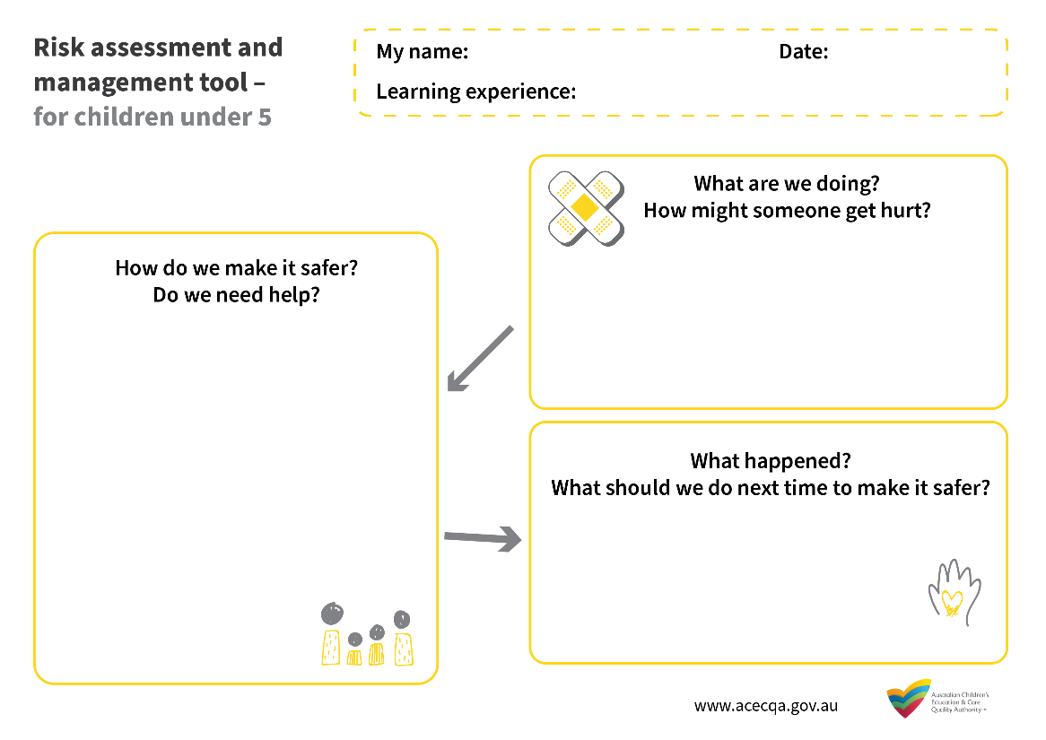

Download, print and share this infographic with educators and staff.

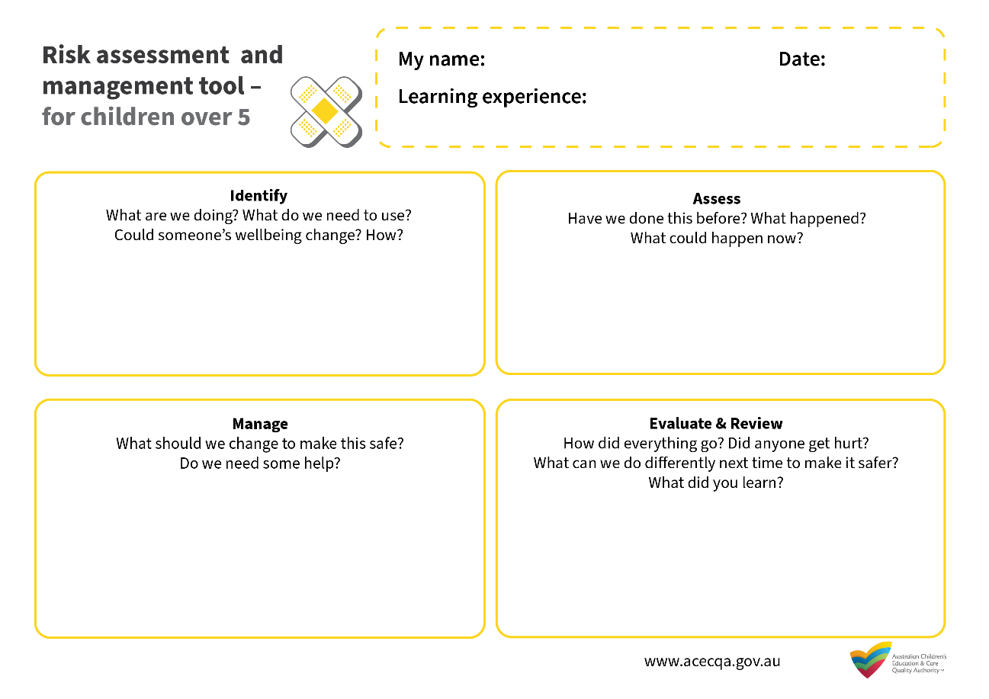

Resources and information

ACECQA | Safe sleep and rest practices  acecqa.gov.au/resources/supporting-materials/infosheet/safe-sleep-and-rest-practices
ACECQA | We Hear You Blog  Beyond the Fence – extending children’s experiences outdoors
ACECQA | Meeting the NQS  acecqa.gov.au/resources/research/meeting-nqs
ACECQA  Child & Nature Alliance of Canada | Quality Area 2 Resources  acecqa.gov.au/nqf/national-quality-standard/quality-area-2-childrens-health-and-safety  Risk-Benefit Assessment for outdoor play: A Canadian Toolkit  outdoorplaycanada.ca/portfolio_page/risk-benefit-assessment-for-outdoor-play-a-canadian-toolkit/
Encyclopaedia on Early Childhood Development | Outdoor Risky Play  child-encyclopedia.com/outdoor-play/according-experts/outdoor-risky-play
Kidsafe NSW | Challenging Play: Risky!  kidsafensw.org/playground-safety/challenging-play-risky/
Kidsafe NSW | Kidsafe Family Day Care Safety Guidelines  kidsafensw.org/home-community/family-day-care/
Lady Gowrie Tasmania | Risk Assessment and Risk Management in Family Day Care  acecqa.gov.au/media/31471
National Health and Medical Research Council (NHMRC) | Staying healthy: Preventing infectious disease in early childhood education and care services (5th Edition)  nhmrc.gov.au/about-us/publications/staying-healthy-preventing-infectious-diseases-early-childhood-education-and-care-services
Play England | Managing risk in play provision: Implementation guide  playengland.org.uk/resource/managing-risk-in-play-provision-implementation-guide/
Red Nose | rednose.org.au
Raising Children Network | Information on road safety and seatbelts for infants, pre-schoolers and school age children.  raisingchildren.net.au/
WorkSafe  Victoria | Early childhood education and care: Safety basics  worksafe.vic.gov.au/
Standards Australia | Risk management - Risk assessment techniques  AS/NZS IEC 31010:2020

References

ACECQA. (2018). Guide to the National Quality Framework (October 2018). Sydney, NSW: ACECQA.
Department of Education, Employment and Workplace Relations (DEEWR). (2009). Belonging, Being and Becoming: The Early Years Learning Framework for Australia. Canberra, ACT: Commonwealth of Australia.
Department of Education, Employment and Workplace Relations (DEEWR). (2011). My Time, Our Place: Framework for School Age Care in Australia. Canberra, ACT: Commonwealth of Australia.

Note: Consider matters such as privacy and family violence situations, and decide how much detail should be recorded. It is likely not appropriate nor necessary to include street addresses for children’s homes in the risk assessment document, however street addresses for services and schools are more likely to be included. In some circumstances, a much more generic description of a pickup location within the risk assessment will be the only appropriate option, as opposed to a child’s street address.

