TEMPLATE

SLEEP AND REST RISK ASSESSMENT
National Quality Review | Sleep and rest risk assessment

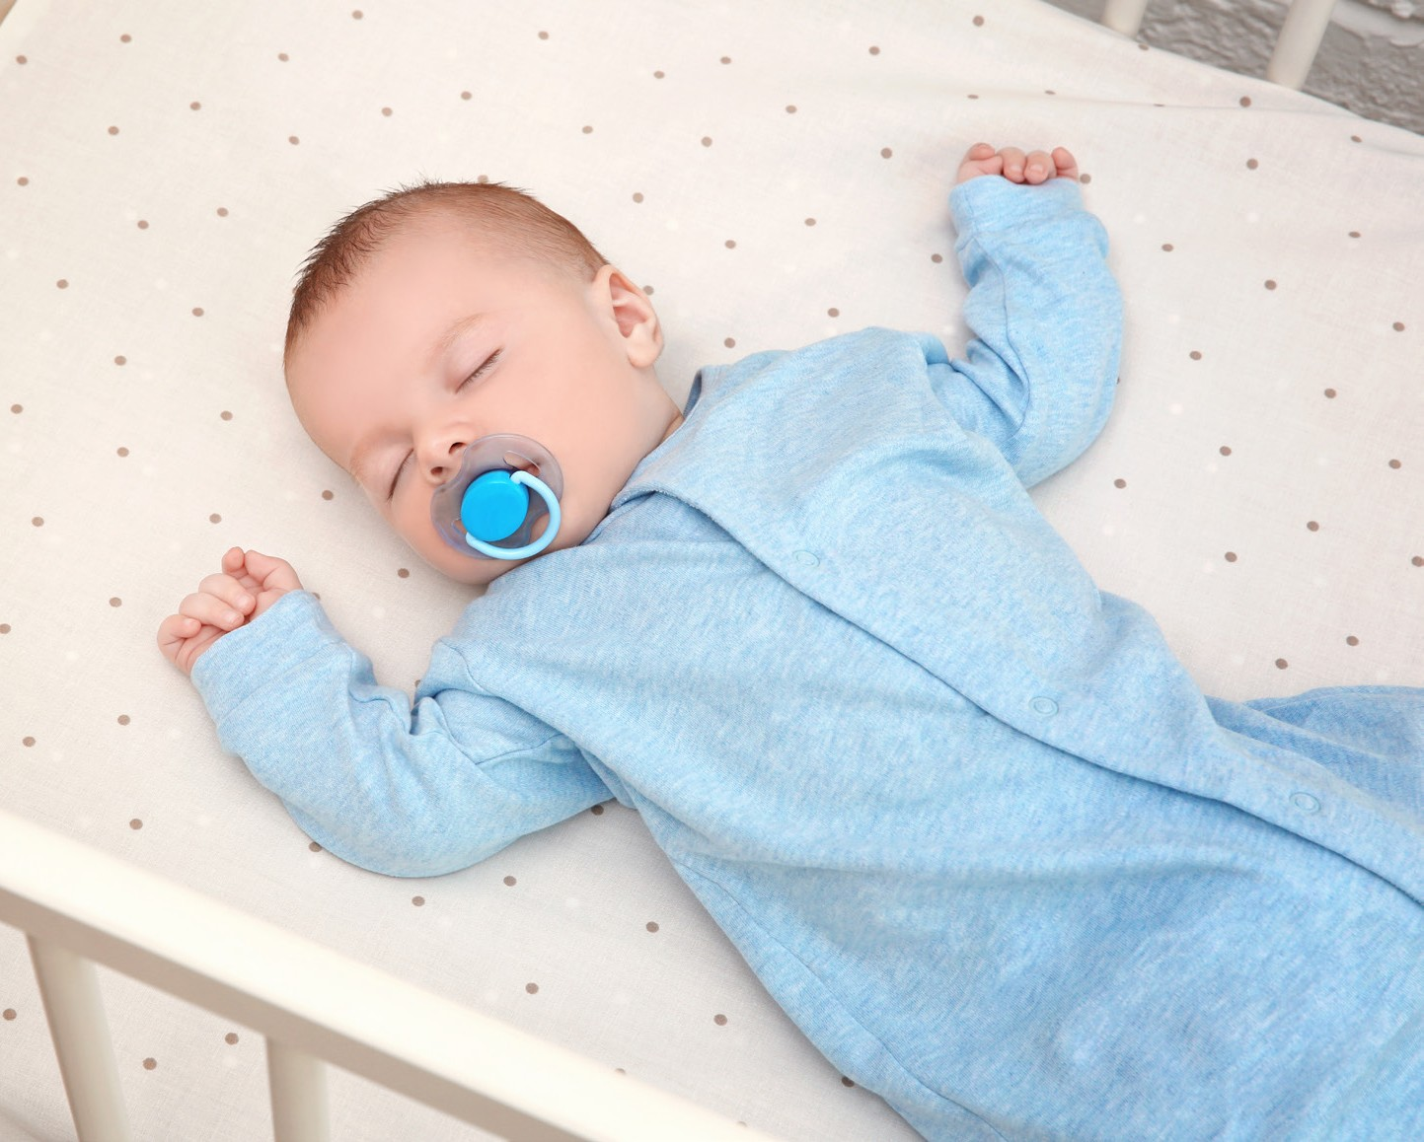
From 1 October 2023, the approved provider, nominated supervisor and family day care (FDC) educator must take reasonable steps to ensure that the needs for sleep and rest of children being educated and cared for by the service are met, having regard to the ages, development stages and individual needs of the
Month Year
children (Education and Care Services National Regulations, regulation 84A). Approved providers must also ensure policies and procedures are in place for managing sleep and rest for children (regulation 168) and take reasonable steps to ensure those policies and procedures are followed (regulation
170).
To ensure the safety of children during sleep and rest, from 1 October 2023, the approved provider must conduct a sleep and rest risk assessment at least once every 12 months, and as soon as practicable after becoming aware of any circumstance that may affect the safety, health and wellbeing of children during sleep and rest. The approved provider must make any necessary updates to the sleep and rest policies and procedures as soon as practicable after conducting the sleep and rest
risk assessment and keep a record of each sleep and rest risk assessment conducted.
The sleep and rest risk assessment must be conducted for each education
and care service or for each FDC residence or FDC venue of the service.
Completing risk assessment and management plans is an ongoing part of good operational practice to ensure the health, safety and wellbeing of children. One way to support this is by using a system of hazard identification and risk management. This can help identify, assess and manage the risk of harm before an incident occurs.
This sleep and rest risk assessment template is designed to assist approved providers and services
in conducting sleep and rest risk assessments. This template is a
starting point and should be adapted to meet the individual needs of your service or FDC residence/venue in line with regulations 84A, 84B and 84C. It is a requirement for services and FDC residences or FDC venues to complete a sleep and rest risk assessment at least once every 12 months, and as soon as practicable after becoming aware of any circumstance that
may affect the safety, health and wellbeing of children during sleep and rest. This document is intended to be an evolving and regularly updated document, to be amended as circumstances change and new hazards arise. Once completed, it is also important to schedule regular reviews of this document to make sure hazards in your service are

identified, risks are managed before they cause harm and identified risks are addressed within policies and procedures (regulation 84B).

USING THIS TEMPLATE
- To begin using this template, inspect and review sleep and rest practices in your service including environments, equipment, policies, procedures, and forms, to identify any potential or existing hazards and check current health guidelines on best practice control measures. Ensure the matters outlined in regulation 84C are considered as well as best practice guidance from recognised authorities (such as Red Nose Australia).
» Adapt this template to be relevant to your service context. To add to this template you can add rows by pressing the tab button on your keyboard from the last column.
- When identifying the action required include the:
» hazard identified
» level of risk (using the risk assessment matrix attached to this document)
» action identified to eliminate/mitigate/manage the hazard or risk
» elimination/control measures
» person(s) responsible for taking the required action
» timeframes for addressing the identified action.
- Once developed, make the template available to all service leaders, educators and staff so that they know what has been assessed as a risk, and how to manage it.
- After the sleep and rest risk assessment is complete, prepare/review the service’s policies and procedures and address within policy and procedure any risks identified in the sleep and rest risk assessment (regulation 84C) as well as other matters required under regulation 84B.
ACECQA’s Risk Assessment and Management tool is a useful resource and should be referred to for more information on how to conduct a risk assessment in your education and care service or residence.
What needs to be considered when conducting a sleep and rest risk assessment from 1 October 2023?
A risk assessment must consider the matters set out below:
- the number, ages and development stages of children
being educated and cared for, including at each education and care service and FDC residence or approved FDC venue of the service
- the sleep and rest needs of children at the service
(including specific health care needs, cultural preferences, sleep and rest needs of individual children and requests from families about a child’s sleep and rest) including at each education and care service and FDC residence or approved FDC venue of the service
- the suitability of staffing arrangements required to adequately supervise and monitor children during sleep and rest periods
- the level of knowledge and training of the staff supervising children during sleep and rest periods
- the location of the sleep and rest areas, including the arrangement of cots and beds within the sleep and rest areas, including at each education and care service and FDC residence or approved FDC venue of the service
- the safety and suitability of any cots, beds and
bedding equipment and having regard to the ages and developmental stages of the children who will use them
- any potential hazards in sleep and rest areas or on a child during sleep and rest periods
- the physical safety and suitability of sleep and rest environments, including temperature, lighting and ventilation at each education and care service and FDC residence or approved FDC venue of the service
- for FDC services that provide overnight care to a child, any risks that the overnight care provided at the family day care residence or approved venue may pose to the safety, health or wellbeing of the child.
For services where overnight care is provided (such as services in hospitals, where shift workers’ children attend
overnight), the risk assessment must address management of risks relating to overnight care, to inform policies and procedures.

RISK MATRIX
A risk matrix is a useful tool to use during the risk assessment process. It helps in identifying the level of risk by looking at the likelihood that a negative event may occur, and the severity of the consequence should it occur.
The Guide to the NQF defines likelihood and consequences in a risk matrix in Section 5: Regulatory Authority power.

Risk Matrix
 | Likelihood
Consequences |  | Rare | Unlikely | Possible | Likely | Almost certain
 | Major | Moderate | High | High | Critical | Critical
 | Significant | Moderate | Moderate | High | High | Critical
 | Moderate | Low | Moderate | Moderate | High | High
 | Minor | Very low | Low | Moderate | Moderate | Moderate
 | Insignificant | Very low | Very low | Low | Moderate | Moderate

LIKELIHOOD
The risk matrix includes five levels of likelihood:
- Rare
- Unlikely
- Possible
- Likely
- Almost Certain.
When thinking about likelihood, the approved provider and service leaders should prioritise actions based on ensuring compliance with the minimum legislative standards, particularly those standards relating to the safety, health and wellbeing of children. The following table is a useful guide.

Likelihood
Rare | Very unlikely – the event may occur only in exceptional circumstances
Unlikely | Improbable – the event is not likely to occur in normal circumstances
Possible | Potential – the event could occur at some time
Likely | Probable – the event will probably occur in most circumstances
Almost certain | Very likely – the event is expected to occur in most circumstances

CONSEQUENCE
The risk matrix also includes five levels of consequences:
- Insignificant
- Minor
- Moderate
- Significant
- Major
This considers the potential impact and how it might affect the safety and wellbeing of children, families, staff and the wider commune

RISK ASSESSMENT TEMPLATE- COT ROOM

Risk assessment
Activity | Hazard identified | Risk assessment (use matrix) | Elimination/control measures | Who? | When?
Charging cords for speaker and iPod are long in the cot room | Possible strangulation | High | - Long charging cords were removed from the rest area and replaced with short cables to remove the risk of choking.  - All cords are hooked up high to ensure nothing hangs. | Nominated Supervisor and All educators | At all times.
Children who are afraid of dark environments. | Children who could possibly have a fear of dark environments could be distressed if placed in dark area of the room | Moderate | - Upon enrolment, families are to be consulted through open conversation with educators regarding their child’s sleep preferences and needs.  - At least one area of the room should be lit with natural light for children who prefer sleeping with light.  - 10-minute checks are conducted for safety and to ensure all children are settled. | Nominated Supervisor and all educators | At all times.
Sheets, linen, comforters, and blankets | Children could possibly put blankets, sheets, linen, or comforters over their face causing them to suffocate or lose their breath in time. | High | - Ensure all sheets and linen are tucked into the mattress adequately.  - Ensure all children are placed in the cot in the right position (down the bottom, feet closest to the end of the cot).  - All comforters and blankets are moved once the child is asleep.  - Adequate air is sufficient in the cot room.  - 10-minute sleep checks are conducted regularly. | Nominated Supervisor and all educators. | At all times
The room temperature and baby’s clothing are not appropriate for the climate | Child overheating during sleep | Moderate | - Refer to the Red Nose information statements: Room Temperature, Protect6ing baby from overheating during sleep, Bedding amount needed for safe sleep  - Ensure child is dressed appropriately for the room temperature  - 10-minute checks are conducted for safety  - Sleep, Rest, Relaxation and Clothing Policy | Nominated Supervisor and all educators | Regular monitoring
Educators putting children to sleep | Educators not having knowledge or adhering to Safe Sleep practices and recommendations when putting baby in cot. May lead to SIDS | High | - Ensure staff members are trained in safe sleep practices  - Centre Director ensures educators understand Red Nose requirements  - 10-mintue checks are conducted for safety  - Sleep policies and procedures | Director, Nominated Supervisor and educators | Include in the induction of new staff members.  Yearly updates of staff knowledge about Red Nose requirements or sleep and rest and SIDS.
Bed Linen | Linen not washed when soiled/ not washed after last child’s of attendance. Children becoming sick from germs. | Moderate | - Linen to be laundered after the child’s last day of attendance each week.  - Soiled linen should not be carried against clothing, instead put linen in a plastic-lined, lidded laundry bin  - Linen is not shared by children without prior washing  - Ensure there is sufficient clean linen for the number of children attending each week | Nominated supervisor and all educators | Include Cleaning Procedure for cots and stretchers as part of induction process for new staff members  Monitor Daily  Closing checklist – the closing staff are to check laundered linen has all been washed and dried or out to dry for the remainder of the day.

RISK ASSESSMENT TEMPLATE- TODDLER ROOM

Risk assessment
Activity | Hazard identified | Risk assessment (use matrix) | Elimination/control measures | Who? | When?
Resource shelves near the beds | Children could push or climb onto the resources shelves near their beds causing it to fall on top of them or resources to fall. | Moderate | - Ensure all beds are 30 cms apart from the furniture.  - Remove the furniture from the area if the room is limited.  - Educate children about rest time rules “no touching toys when we are resting”. | All educators in the room | At all times.
Trolleys in the room | This is a climbing and tripping hazard in the room while children are resting/ sleeping.  Children could push or climb onto the trolley. | Moderate | - Ensure all beds are 30cm apart from the trolley.  - Ensure all educators educate the children in rules around the trolley.  - Remove the trolley after lunch to ensure it is not in the room at this time of day. | Nominated Supervisor and all educators | At all times.
PowerPoints in the room | Electrocution | Moderate | - Ensure all PowerPoints are covered with safety caps.  - If installing new ones – ensure they are at a high point on the wall and not low.  - Ensure beds are not near PowerPoints. | Nominated Supervisor and all educators | Opening and closing checks  At all times
Beds are not regularly cleaned | Regular cleaning of environmental surfaces help to prevent people getting sick from germs, preventing and controlling germs. | Moderate | - Clean beds with an approved neutral cleaner and stack safely at the end of rest time | Nominated Supervisor and all educators | Everyday monitoring  Clean the beds daily
Bed Linen | Linen not washed when soiled/ not washed after last child’s of attendance. Children becoming sick from germs | Moderate | - Linen to be laundered after the child’s last day of attendance each week.  - Soiled linen should not be carried against clothing, instead put linen in a plastic-lined, lidded laundry bin  - Linen is not shared by children without prior washing  - Ensure there is sufficient clean linen for the number of children attending each week | Nominated supervisor and all educators | Include Cleaning Procedure for cots and stretchers as part of induction process for new staff members  Monitor Daily  Closing checklist – the closing staff are to check laundered linen has all been washed and dried or out to dry for the remainder of the day.

RISK ASSESSMENT TEMPLATE- PRESCHOOL ROOM

Risk assessment
Activity | Hazard identified | Risk assessment (use matrix) | Elimination/control measures | Who? | When?
PowerPoints in the room | Electrocution | Moderate | - Ensure all PowerPoints are covered with safety caps.  - If installing new ones – ensure they are at a high point on the wall and not low.  - Ensure beds are not near PowerPoints. | Nominated Supervisor and all educators | Opening and Closing Checks  At all times
Trolleys in the room | This is a climbing and tripping hazard in the room while children are resting/ sleeping.  Children could push or climb onto the trolley. | Moderate | - Ensure all beds are 30cm apart from the trolley.  - Ensure all educators educate the children in rules around the trolley.  - Remove the trolley after lunch to ensure it is not in the room at this time of day. | Nominated Supervisor and all educators | At all times.
Resource shelves near the beds | Children could push or climb onto the resources shelves near their beds causing it to fall on top of them or resources to fall. | Moderate | - Ensure all beds are 30 cms apart from the furniture.  - Remove the furniture from the area if the room is limited.  - Educate children about rest time rules “no touching toys when we are resting”. | All educators in the room | At all times.
Beds are not regularly cleaned | Regular cleaning of environmental surfaces help to prevent people getting sick from germs, preventing and controlling germs. | Moderate | - Clean beds with an approved neutral cleaner and stack safely at the end of rest time | Nominated Supervisor and all educators | Everyday monitoring  Clean the beds daily
Bed Linen | Linen not washed when soiled/ not washed after last child’s of attendance. Children becoming sick from germs | Moderate | - Linen to be laundered after the child’s last day of attendance each week.  - Soiled linen should not be carried against clothing, instead put linen in a plastic-lined, lidded laundry bin  - Linen is not shared by children without prior washing  - Ensure there is sufficient clean linen for the number of children attending each week | Nominated supervisor and all educators | Include Cleaning Procedure for cots and stretchers as part of induction process for new staff members  Monitor Daily  Closing checklist – the closing staff are to check laundered linen has all been washed and dried or out to dry for the remainder of the day.
 |  | Make selection
 |  | Make selection

Plan and review
Plan prepared by | Full name Signature  Role/position |  | Date
Prepared in consultation with | Full name Signature  Role/position
Communicated to all relevant staff | Yes | No | Comment (if needed)

Plan and review
Risks identified from this risk assessment have been addressed within policy and procedure (regulation 84C) as well as other matters required under regulation 84C, including:
- the number, ages and development stages of children being educated and cared for, including at each education and care service and FDC residence or approved FDC venue of the service
- the sleep and rest needs of children at the service (including specific health care needs, cultural preferences, sleep and rest needs of individual children and requests from families about a child’s sleep and rest) including at each education and care service and FDC residence or approved FDC venue of the service
- the suitability of staffing arrangements required to adequately supervise and monitor children during sleep and rest periods
- the level of knowledge and training of the staff supervising children during sleep and rest periods
- the location of the sleep and rest areas, including the arrangement of cots and beds within the sleep and rest areas, including at each education and care service and FDC residence or approved FDC venue of the service
- the safety and suitability of any cots, beds and bedding equipment and
having regard to the ages and developmental stages of the children who will use them
- any potential hazards in sleep and rest areas or on a child during sleep and rest periods
- the physical safety and suitability of sleep and rest environments, including temperature, lighting and ventilation at each education and care service and FDC residence or approved FDC venue of the service
- for FDC services, that provide overnight care to a child, any risks that the overnight care provided at the family day care residence or approved venue may pose to the safety, health or wellbeing of the child.
Next sleep and rest risk assessment to be conducted before

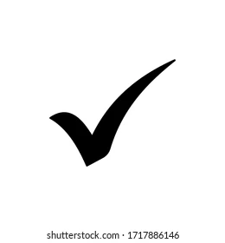
Yes No
Comment if needed.

*AND as soon as practicable after becoming aware of any circumstance that may affect the safety, health and wellbeing of children during sleep and rest

